Campus Traffic Flow Optimization

The written report can have common parts among team members, but each team member should complete his or her own report. Include the following in the report:
1. Describe the project idea that you were aspired to do.
2. Who are the team members? What roles did each of them play? What tasks were assigned to each of them? What is your reflection of the team (people and process)?
3. What problem did your team identify? Why is it a problem? What ISE knowledge or systems thinking concepts did you think could help?
4. What improvement goal(s) did your team come up with? How did they compare to your original goal? Are you satisfied with the improvement goal? Why or why not?
5. Describe the project execution, in terms of Deming’s Plan-Do-Study-Act cycle. What were involved in the planning stage? What ISE knowledge/methods or systems thinking concepts were applied for the improvement project? How were the improvement methods carried out? How did your team reflect on the progress, successes, and failures? What action will you take from the results of the project?
6. Please include in the report your project flowcharts, Gantt chart (planned and actual timetable), cost estimation sheet, meeting minutes, the list of measures of success, data collected, log or journal of actions that tracks what works and what doesn’t.
7. Include an evidence of your project, such as a product, a video of an event, photos etc. If you are not sure what to include, discuss with the instructor.
8. How were the project results compared to the plan you set out to improve? To what extent did you address the problem? What did you learn?
9. Are you satisfied with what your team was able to achieve in the project? Please explain.
10. What ISE knowledge or systems thinking concepts work in the project? What ISE knowledge or systems thinking concepts did NOT work in the project?
11. What knowledge do you wish to learn more for future improvement projects?
12. Does this project help you better understand your interest in ISE?
13. Does this project help you by creating a changed or new perspective about your study plan or future career interest?
14. Overall, how would you evaluate this learning experience?
15. Please include a rating of each team member’s performance for the project. The rating scale is:
1 = Far below fair contribution
2 = Below fair contribution
3 = Meeting fair contribution
4 = Exceeding fair contribution
5 = Far exceeding fair contribution
16. Please provide your suggestion to future students doing this project exercise.
17. Please provide your suggestion or comments to the instructor regarding the project exercise.

Table of Contents

Project Plan, Development and Goals...………………….…………………..…...…….. 4
Team Members and Responsibilities ……………………..……………………...……... 5
Activity/Meeting Journal……………………………....…………….……………....……. 6
Task Procedure Flowchart……………………………....…………….…………...….…...8
Gantt Chart ..………………………………………………………………………..…….... 9
Systems Analysis…………………………………………………….……………….…... 14
Measures of Success.……....……………………………………….……………….…... 15
Data Collection.…………………………………....……………….……………...….…... 16
Flowchart .…………………………………………....……………….……………….…... 21
Traffic Survey ………………….……………..…………………………………...………..23
Solutions and Result…………………………………………………………………….... 29
Route Optimization...………...…………………………………………………...……..... 30
Signaling and Bike Safety Quiz…………………………………………………………....33
Conclusion and Findings ….……………………………………..…………………....…. 37
Individual Reflections………….…………..…………………………………………..….. 38
Works Cited………………….….…………..…………………………………………..…..41

Project Plan, Development and Goals

Almost everyday on campus, USC students suffer through these awkward moments where we bump into each other on our bikes and skateboards. Even broader than that, with thousands of students packed onto Trousdale at a busy afternoon creates a hassle for everybody. Thus, our objective is to improve the system of commuting on campus. We have three main strategies to achieve this: First, we will try to implement a system to avoid bikers from crashing into each other by experimenting with different signaling processes. Next, we will attempt to decrease the the number of bikers-pedestrian crashes by exploring different methods of routes that bikes can take: whether that be guiding them to less busy routes on campus or by trying to come up with a way that will make them actually use the bike paths. And finally, we can apply the data collected from our surveys and propose plans to appease bikers and skateboarders’ accessibility to walkways on campus.

Team Members and Responsibilities

The team members of our project are Vatsal Gupta, Raven Castro, Ali Alghanim, Naman Jain, and Aprylle Salvador. Our initial project plan and development was done collectively in group meetings because we needed to decide on the backbone and structure of this project as a whole. Each of us took our part in the data collection and observation aspect of our project, as we all individually collected data at different times and different days at Dean’s List to get the most accurate representation of the traffic flow. Deciding on the solutions to the problem at hand, and measuring their success were also group efforts planned out in numerous group meetings.

While many of the larger, deciding-factor tasks were completed in group meetings, we assigned each other the smaller tasks that could be done individually to be the most efficient. For instance, Raven designed the survey, as well as came up with the survey questions, and we all distributed it to our groups of interest. Naman and Vatsal designed the flowcharts for our project and I designed the Gantt Chart for our meetings. Ali designed our project presentation and Vatsal also came up with the signaling and bike safety quiz. Overall, the team worked very well together and all of the group meetings were productive and advanced our project. The individual work we assigned each other was done on time so we were able to critique each other’s work in a following group meeting to make sure everything was in line.

Activity and Meeting Journal

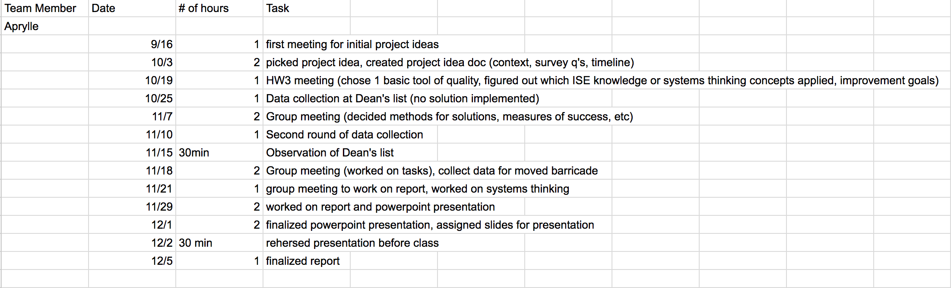

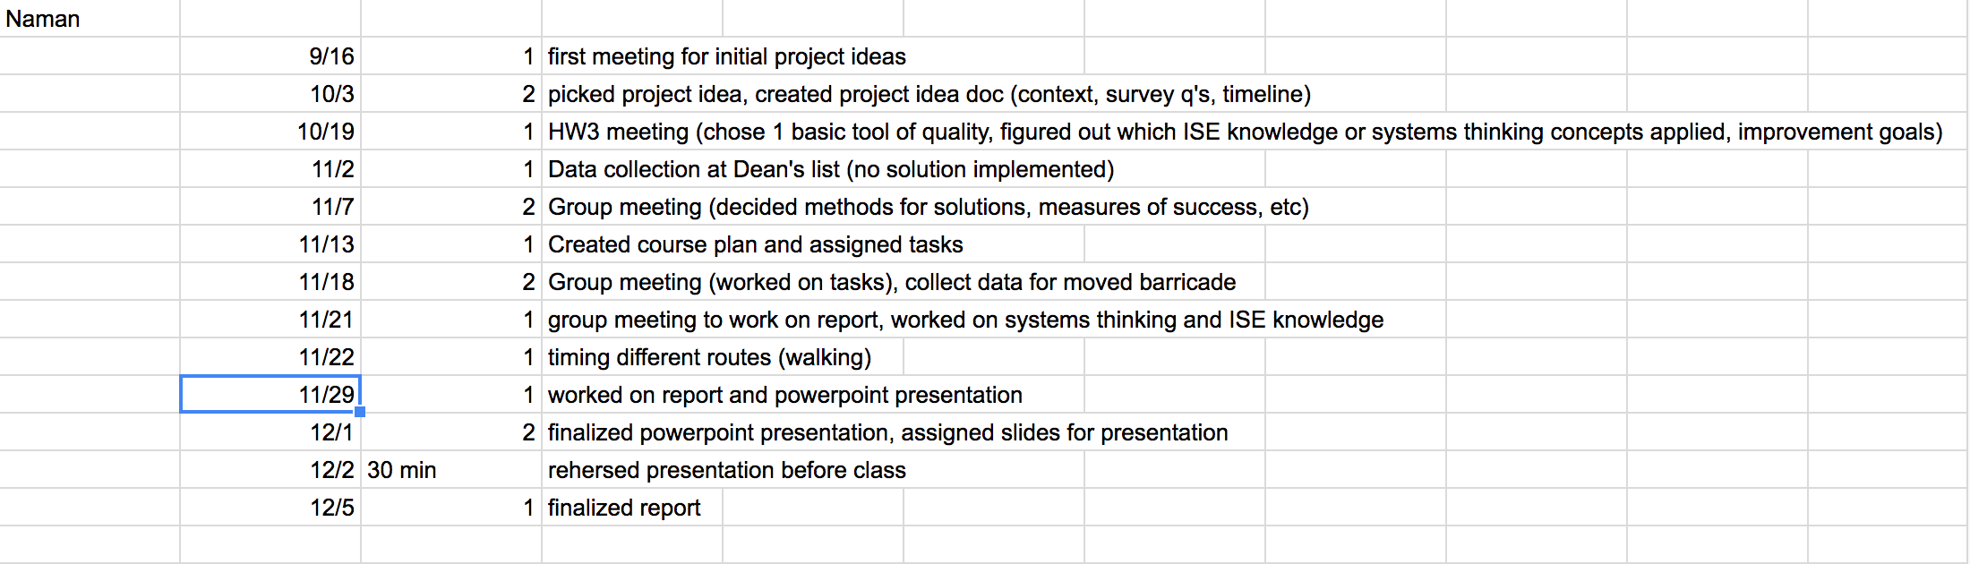

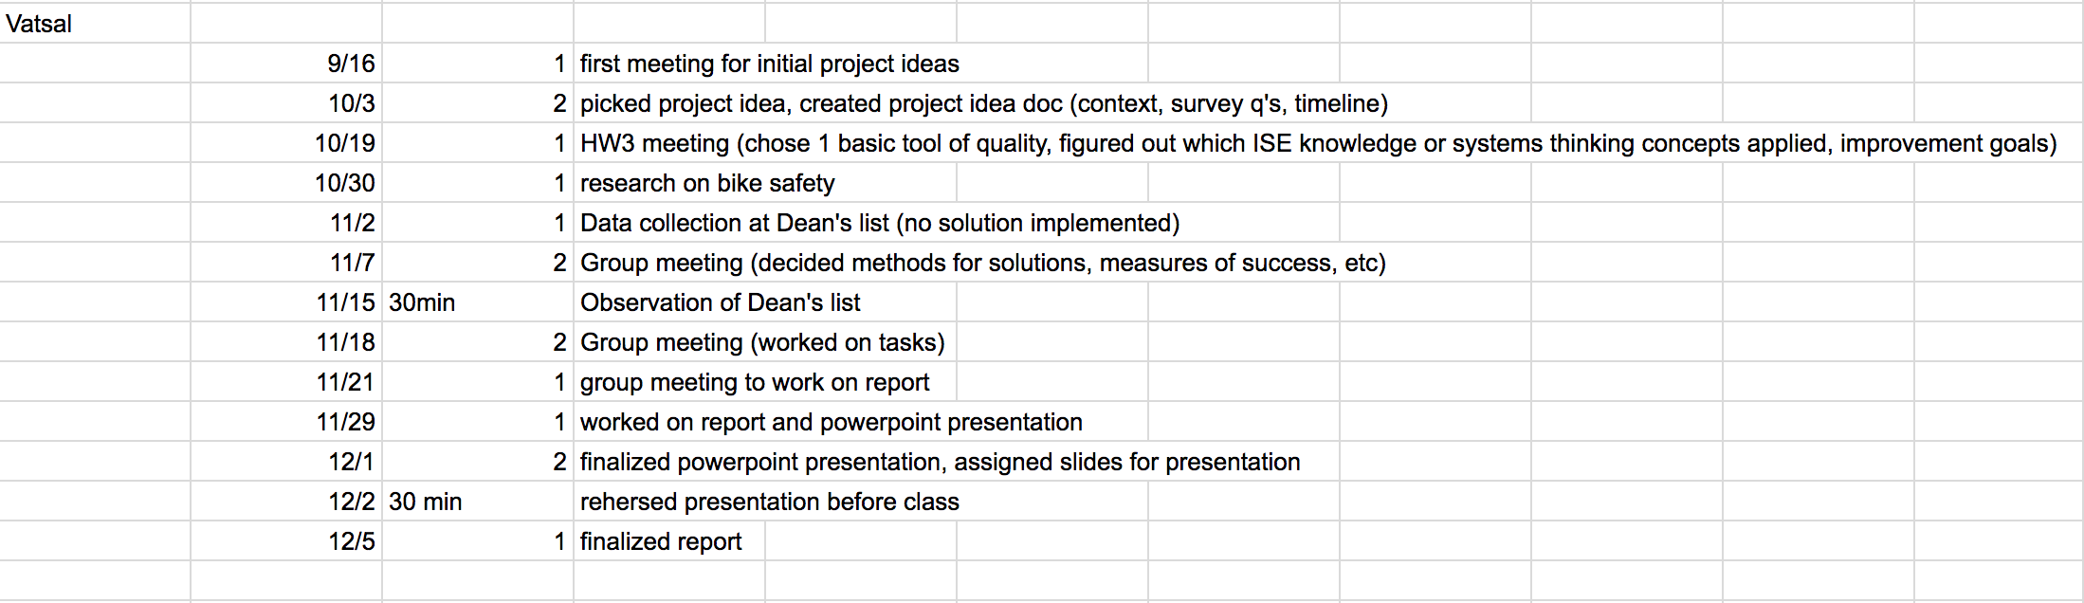
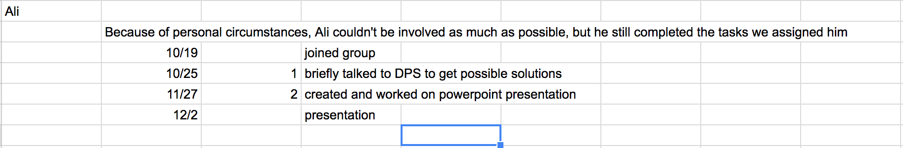
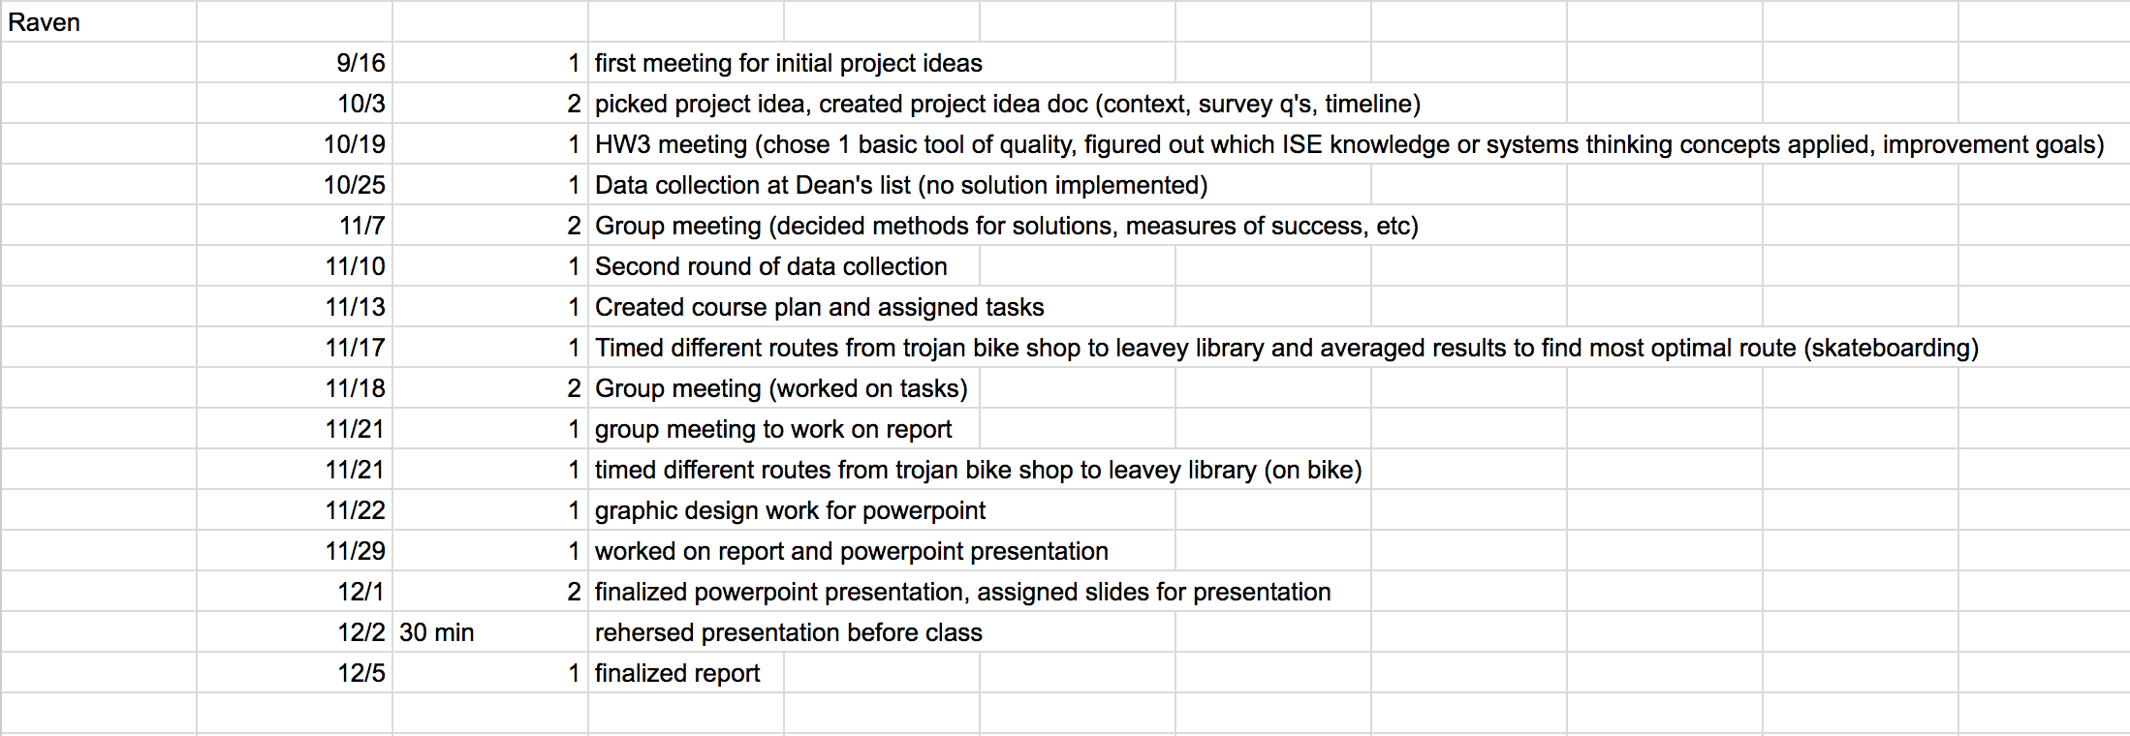

Task Procedure Flow Chart

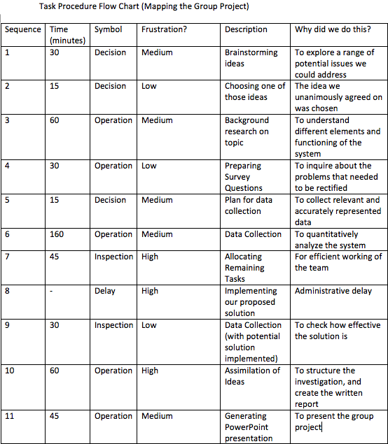

Gantt Chart

https://app.teamweek.com/#p/jguca7kpqrwc2pi9ppom

September
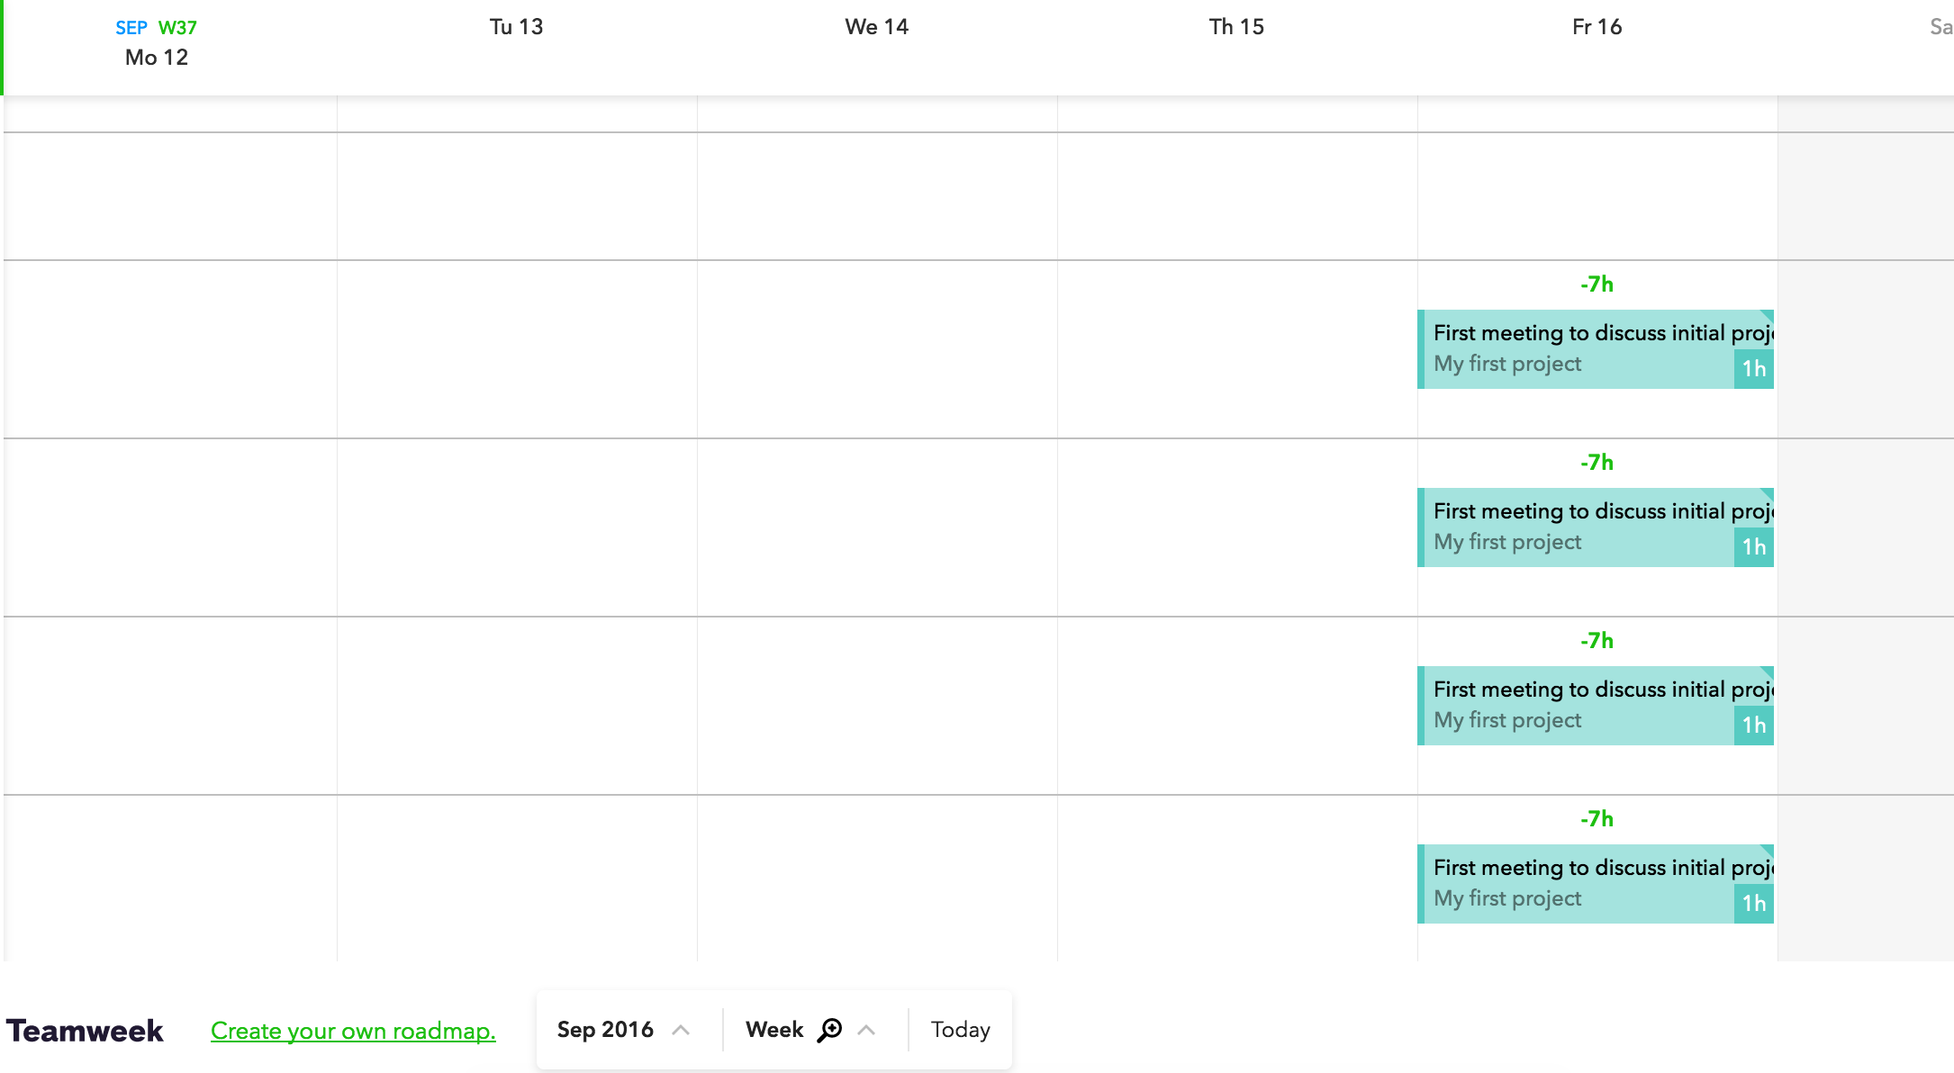
October
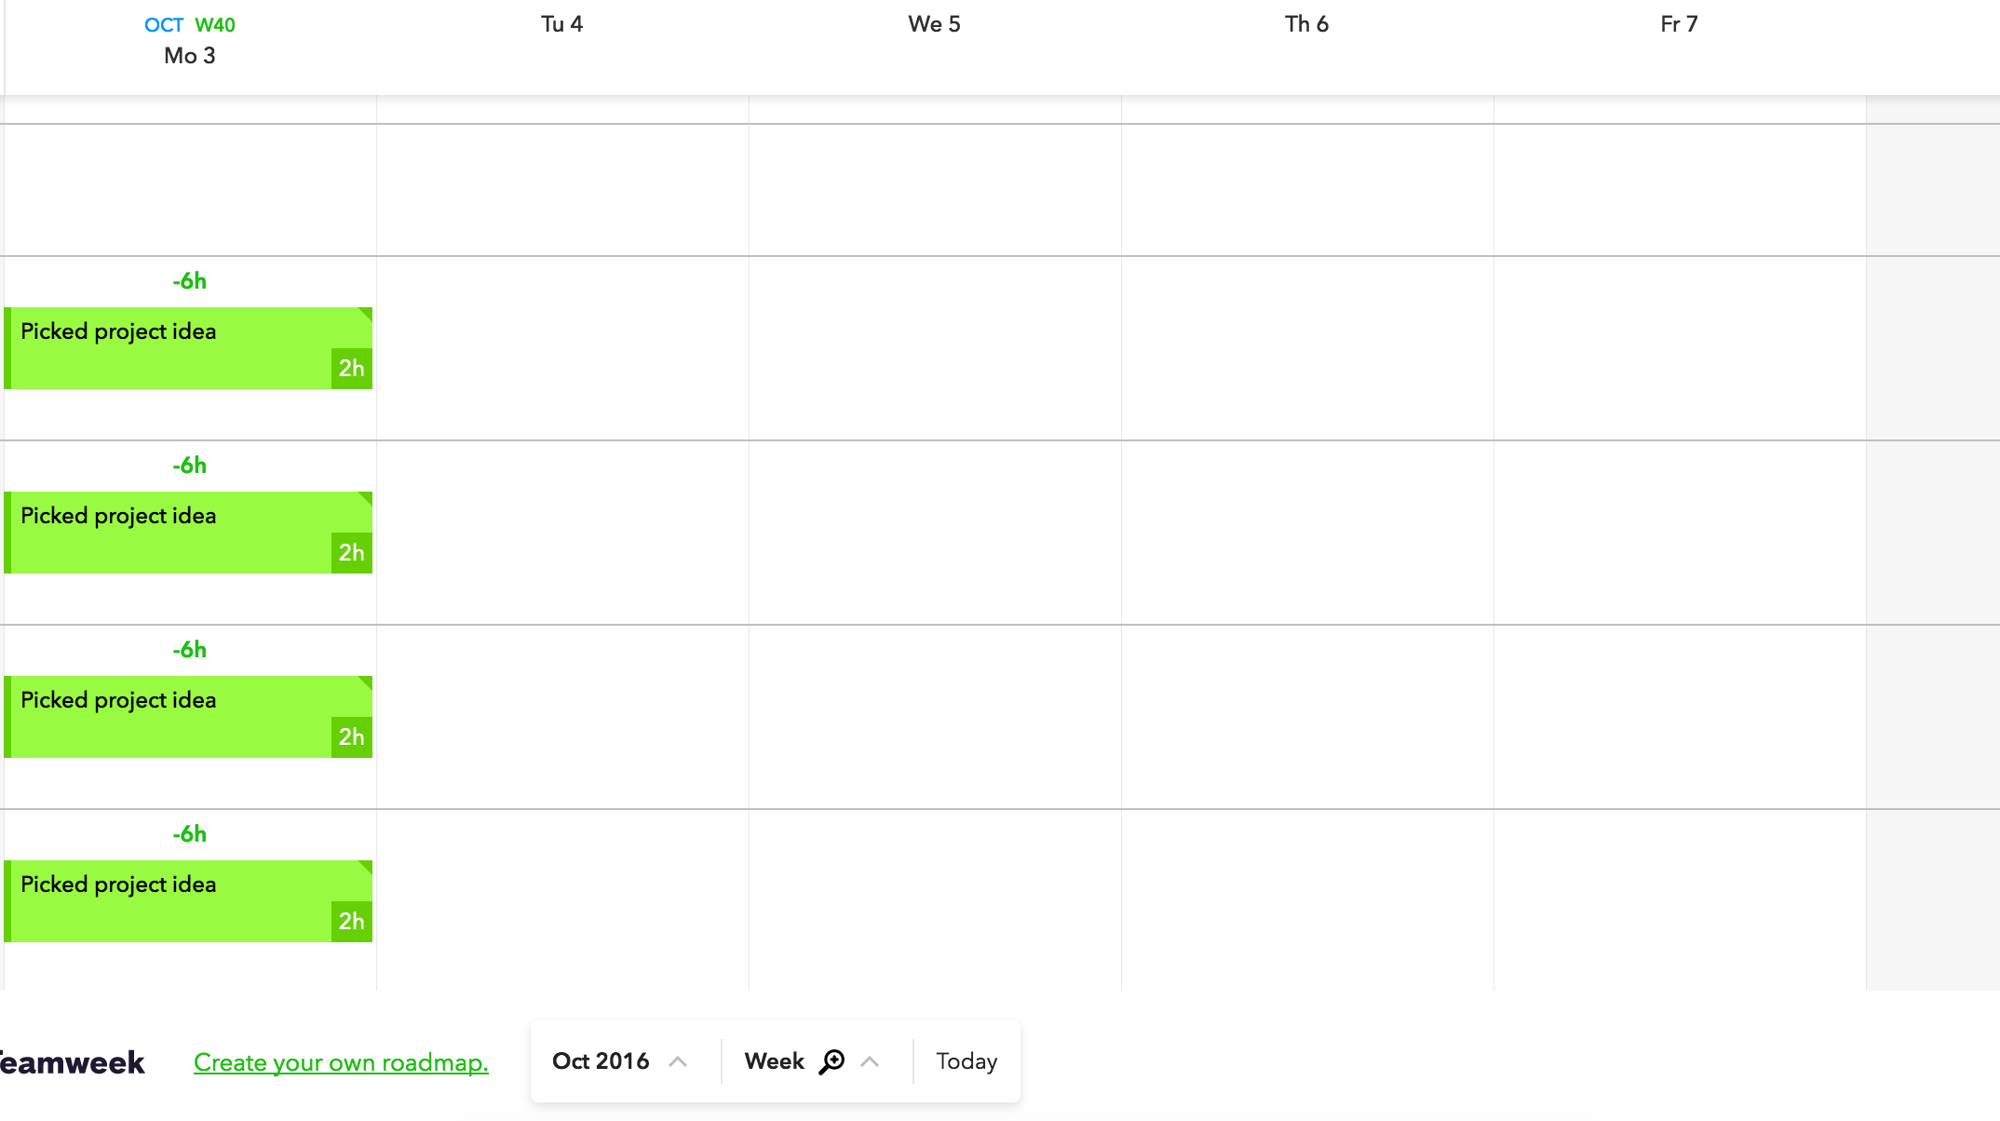

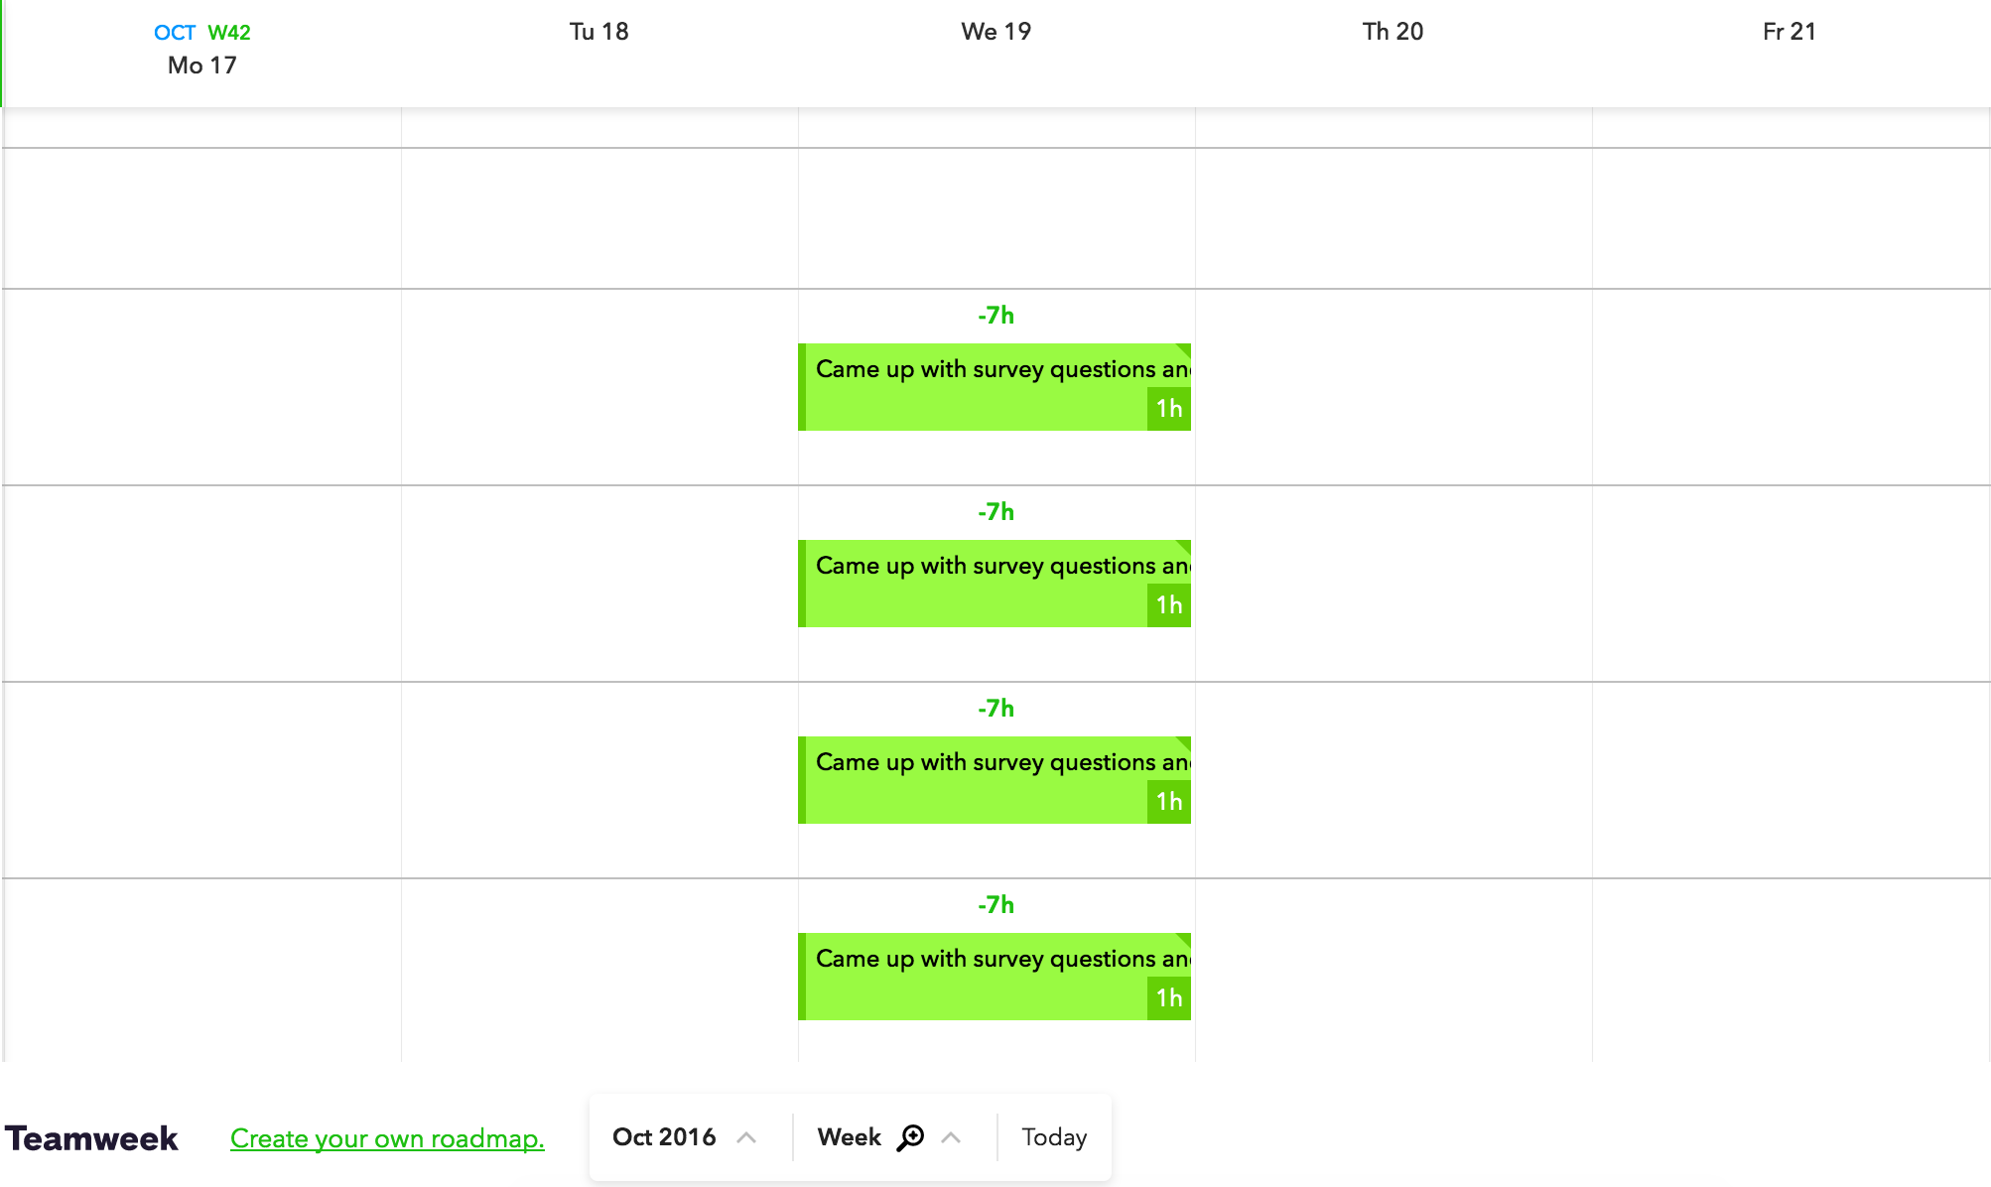
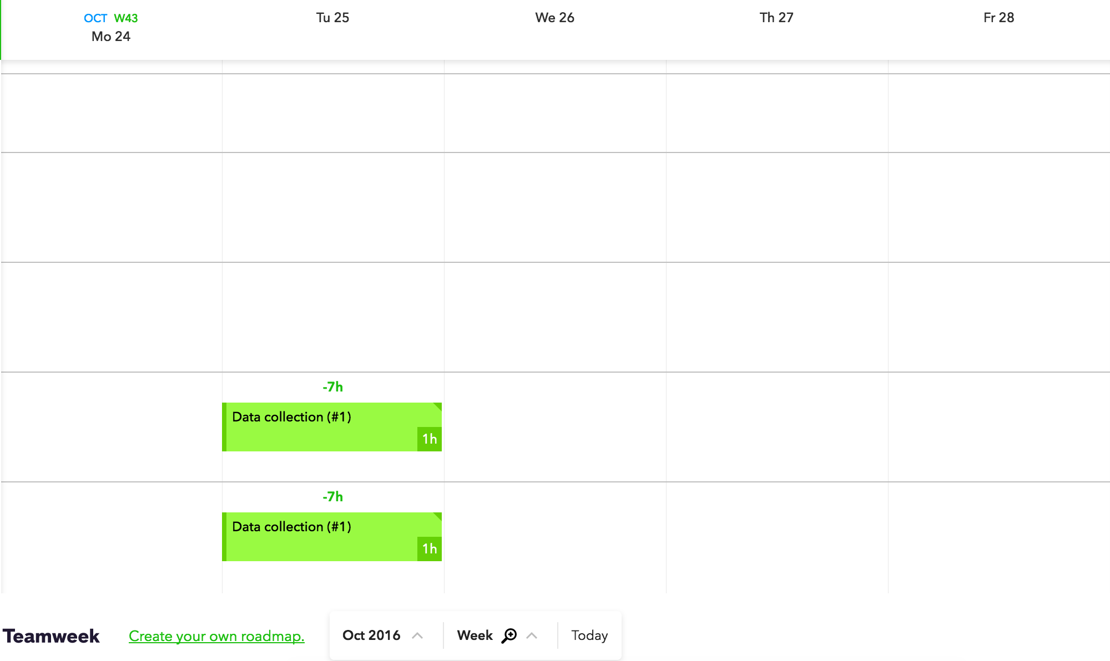

November
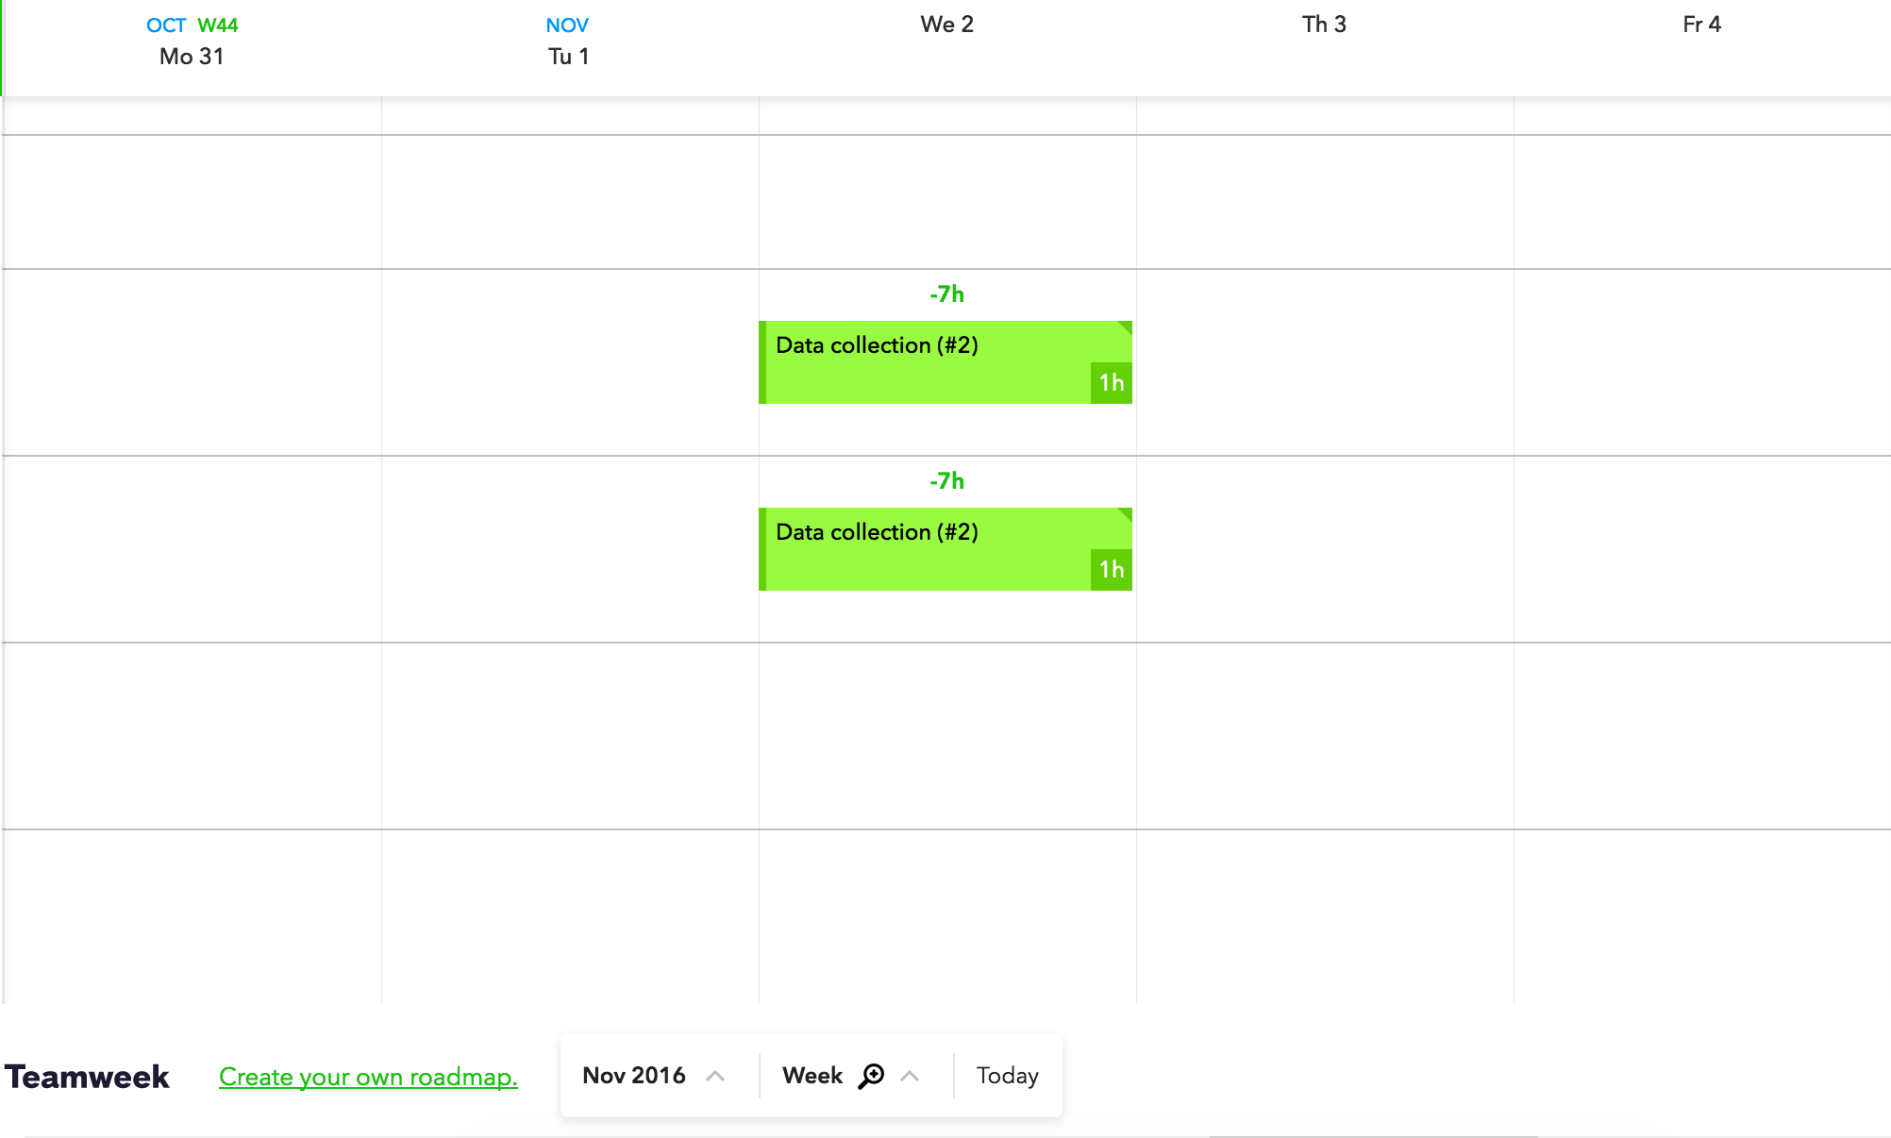
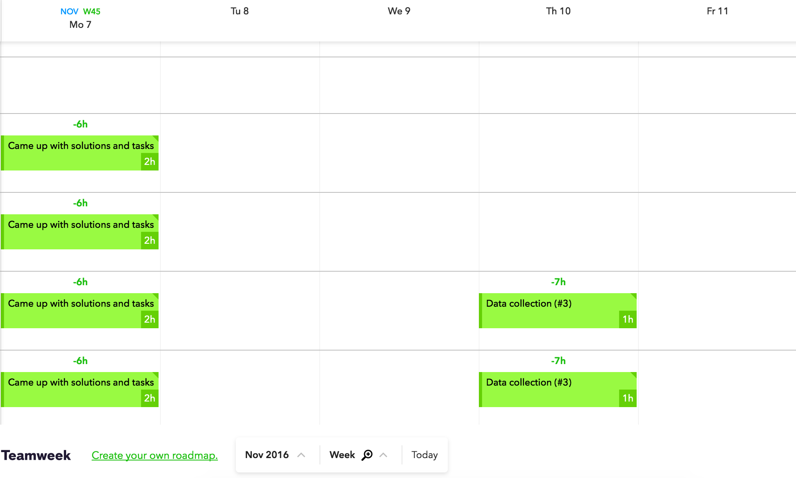
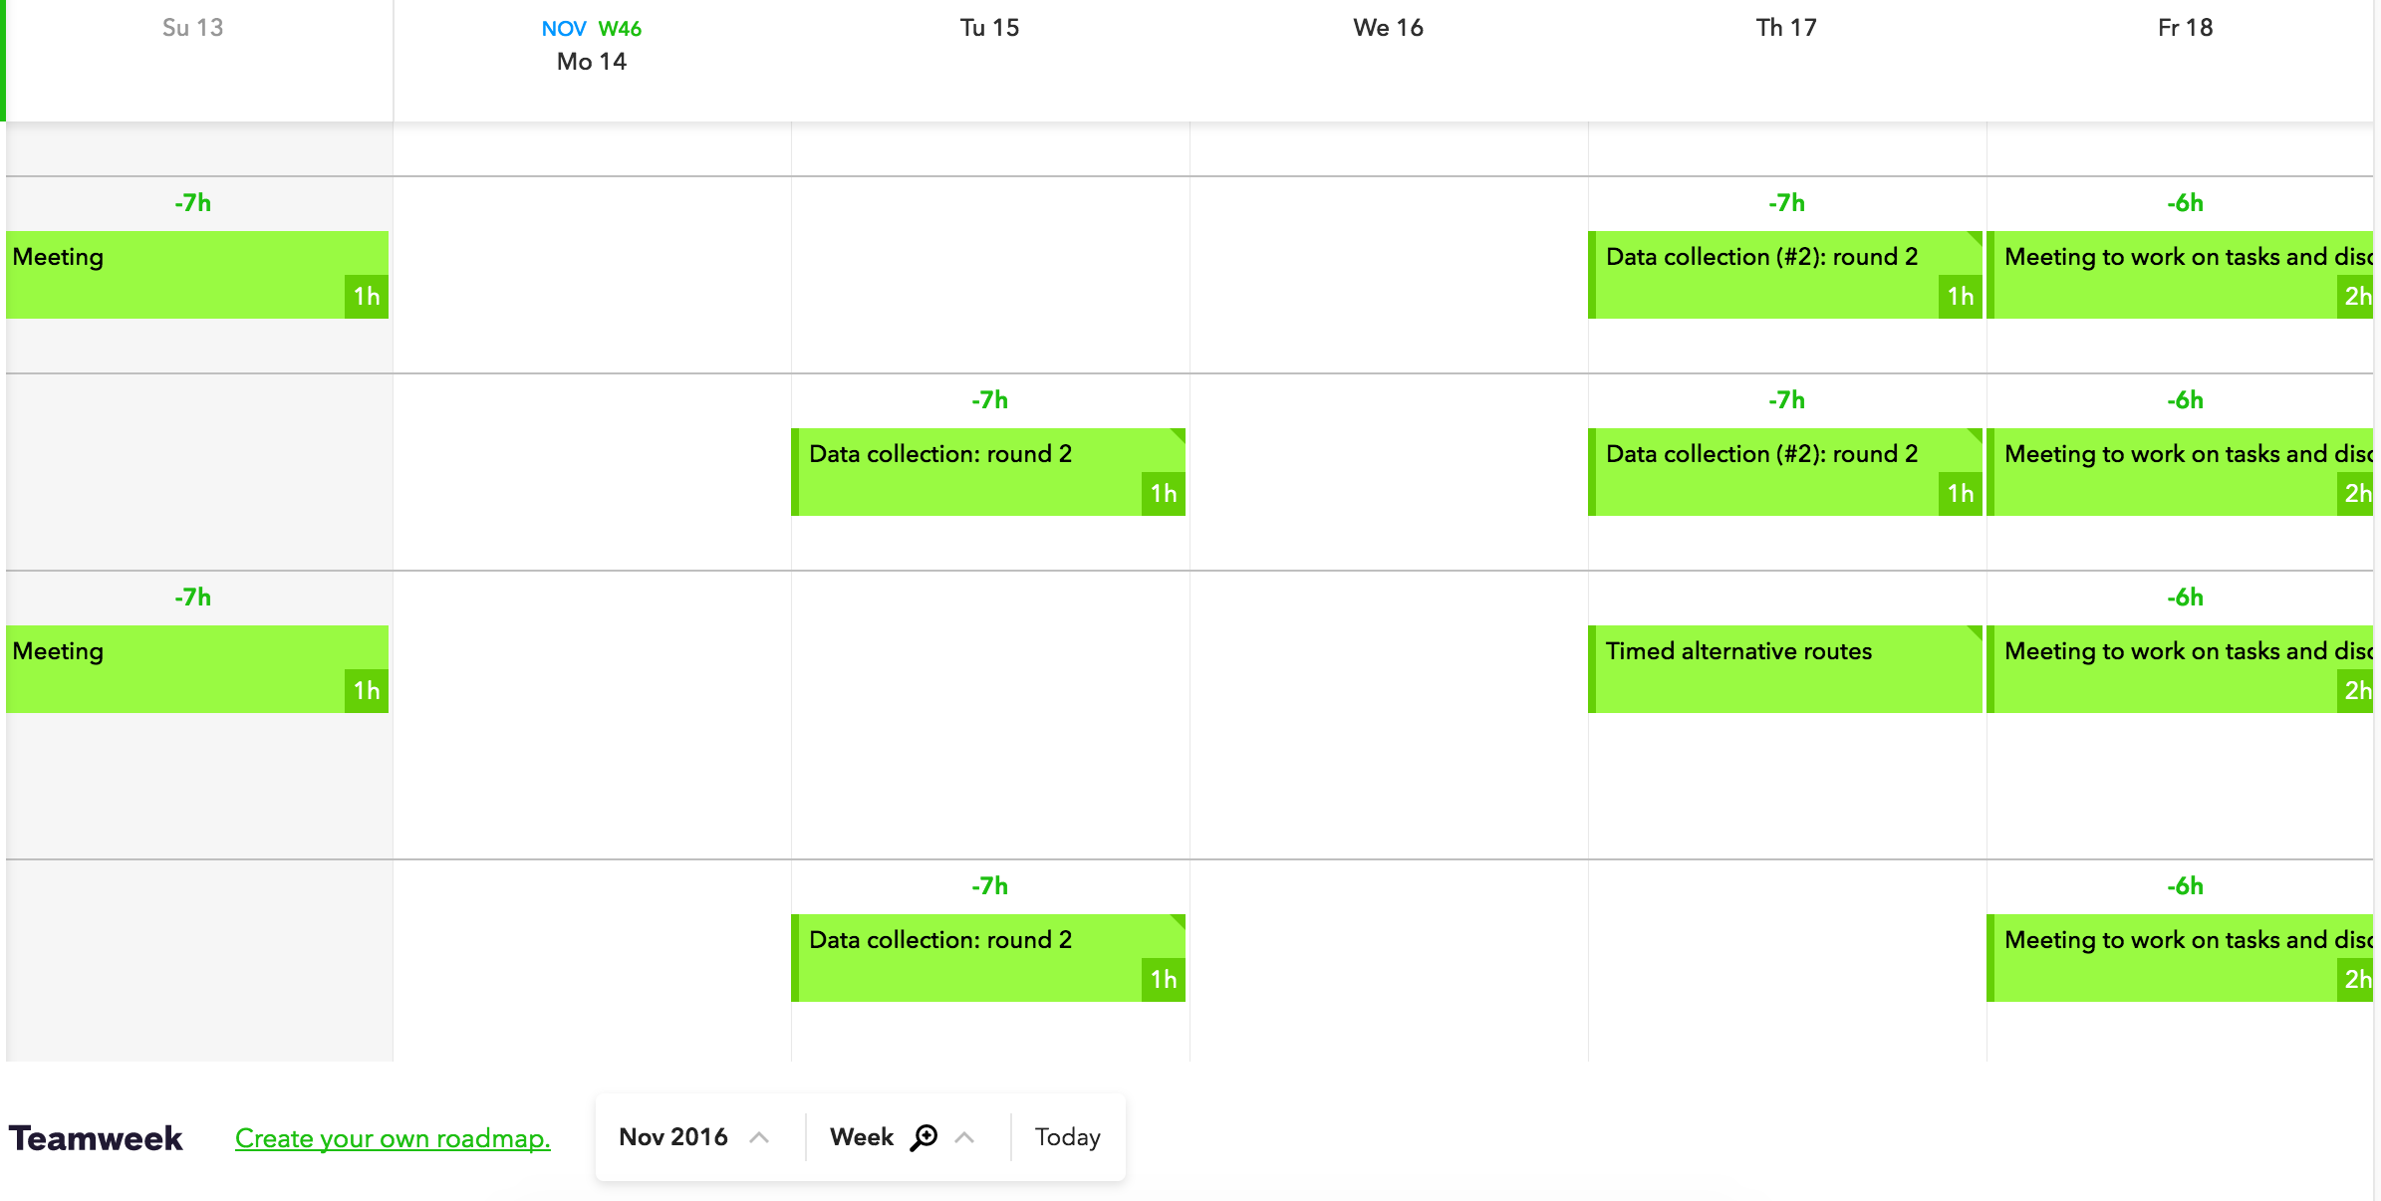
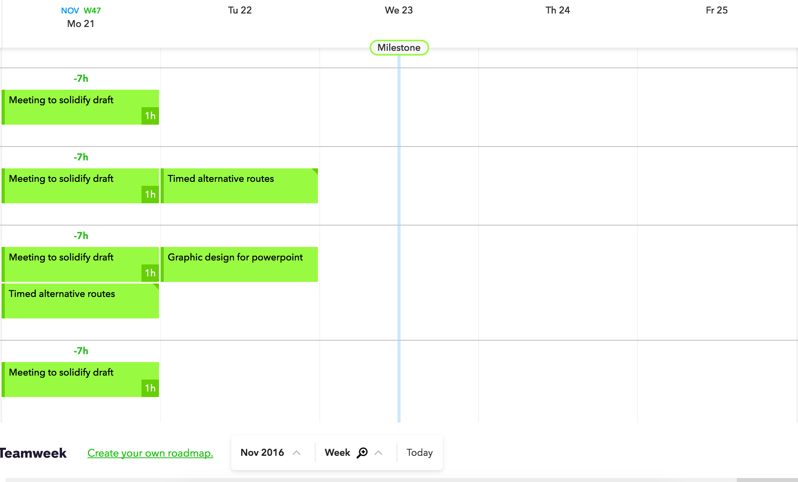

December
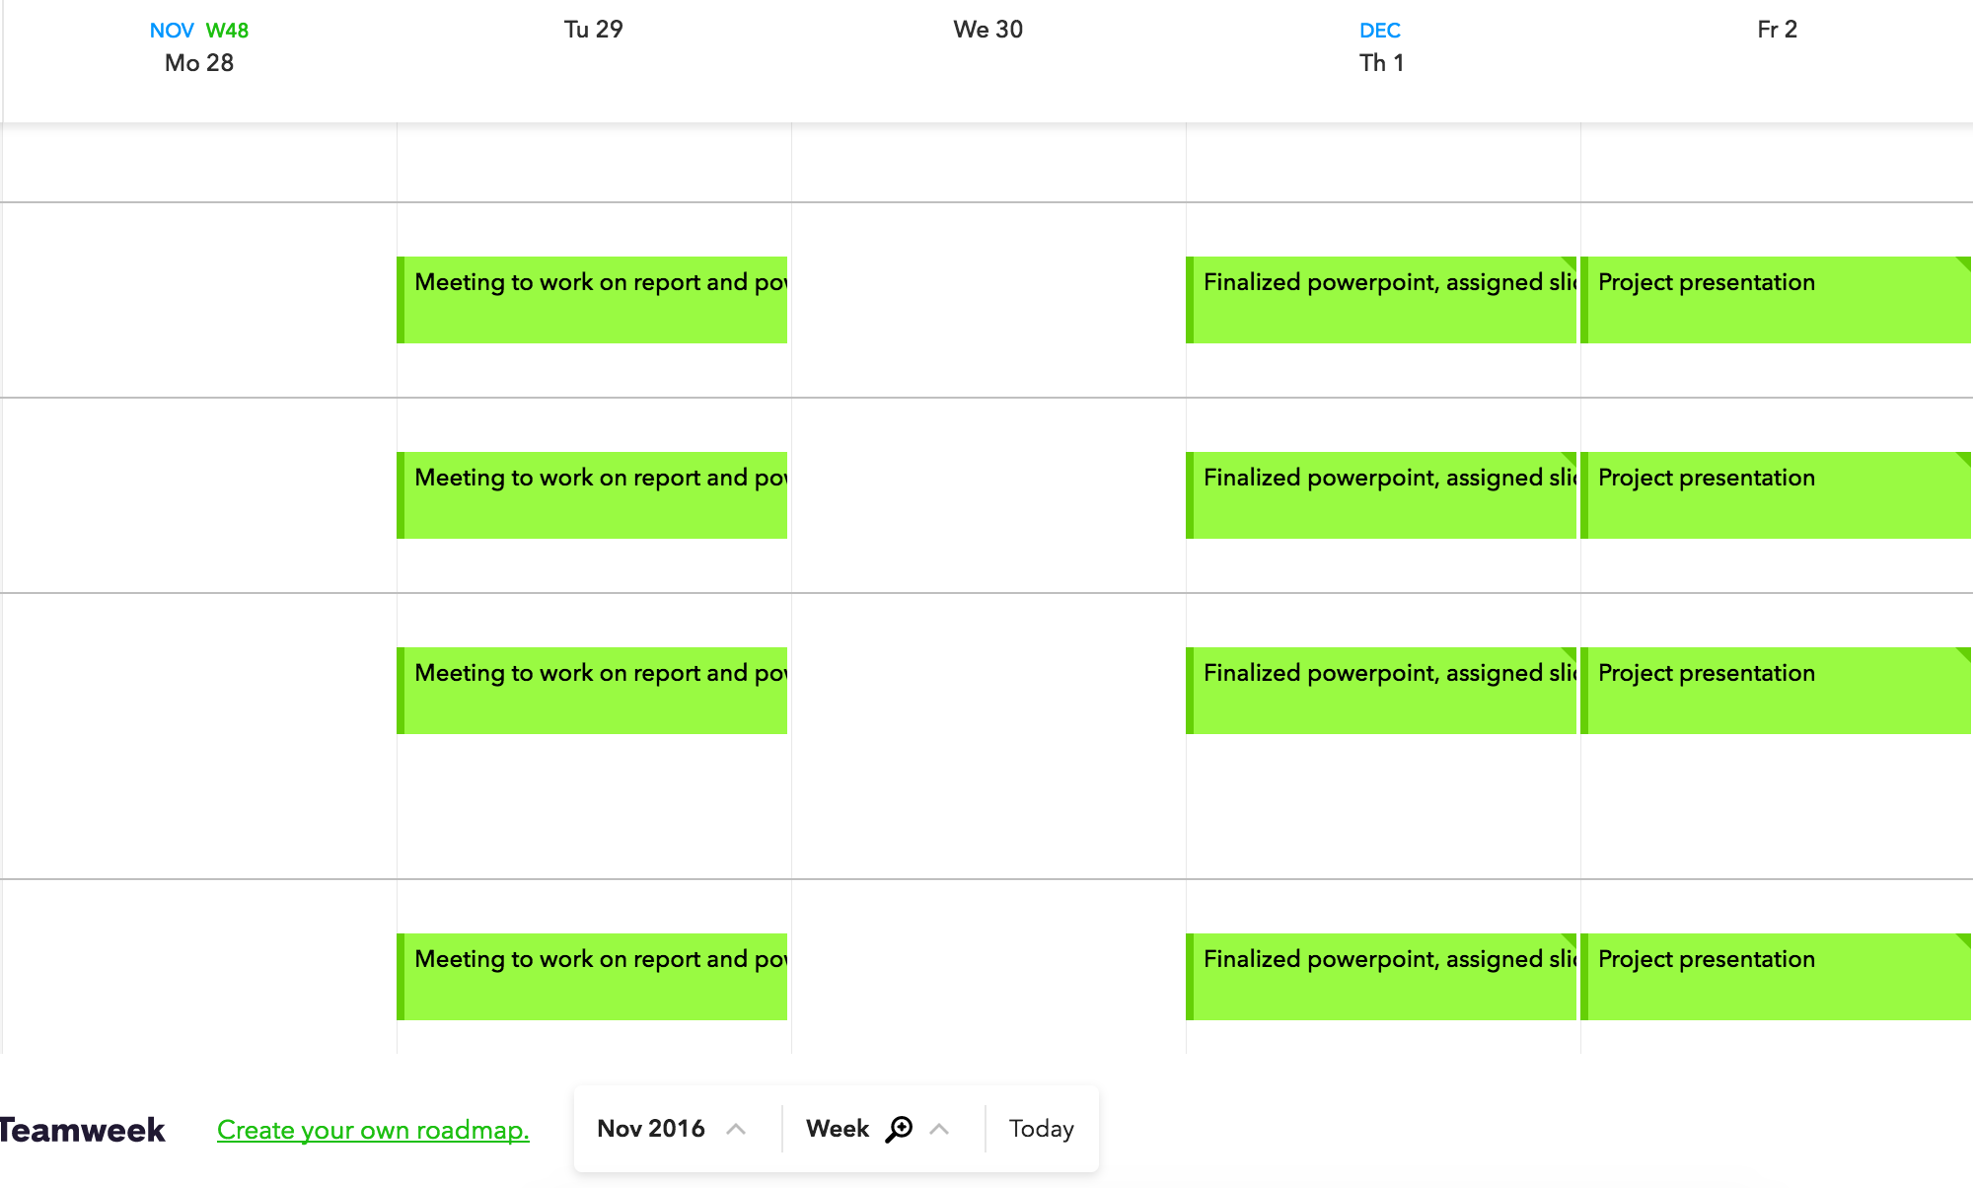

Systems Analysis

ISE Concepts used:
Several ISE concepts can be applied to our project topic on increasing safety for commuters and increasing the efficiency of traffic flow on campus. The broad ISE concept that we believed could be applied is efficiency - ensuring the smooth flow of traffic by reducing the number of collisions or mishaps, or finding the optimal route for commuters to reach their destination. A lot of data collection is required for us to understand the issue and make the system better, thus Process Improvement by statistical methods is an apt ISE concept we utilized especially in coming up with solutions based on the data we collected.

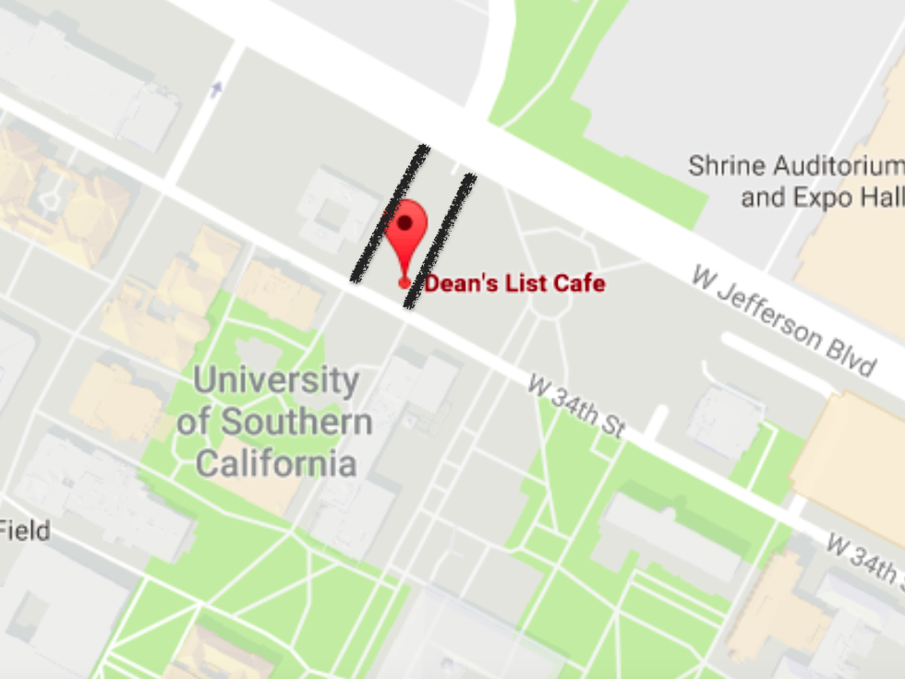
We also used the plan-do-study-act cycle when assigning responsibilities and tasks during the beginning phases of our projected. Check sheets were used as the main form of data collection. Diagrammatic representation of the system of traffic flow is important to understand the problem and this was achieved by the Causal Loop Diagrams, Fishbone Diagrams, and Pareto Charts we utilized in our analysis. To ensure our group worked efficiently, we used a Task Procedure Flowchart to keep track of the different activities and functioning of the group. We also used surveying techniques to gather more information of the issue at stake. Overall, the research for our project provided us insights in the field of Operations Research, as we used Operations Research techniques (aforementioned) to make traffic flow more efficient.

We also used lean thinking when coming up with our solutions to the given problem. By clearing obstructions like barriers we eliminated the waste that got in the way of the system of bikers, pedestrians, and skateboarders commuting to and from campus. Also by creating a one way system where bikers can only go into campus on one side of Dean’s List and out on the other side, we eliminated the waste of bikers, pedestrians, and skateboarders trying to avoid people going the opposite way. Both of these solutions provide greater satisfaction to all parties involved because they minimize the frustration and extra time wasted that comes with navigating through people and barriers while trying to get to campus.

Improvement Goals

After identifying the problem, the team tried to decide what our goals for improvement should be. Our primary goal was to ensure the safety of all commuters on campus (including bikers, skateboarders, etcetera). Keeping this objective in mind, we found a location on campus where we had personally experiences commuting mishaps, or mini-accidents taking place. We chose the pathways on either side of Dean’s List Café (connecting W Jefferson Blvd and W 24th St). We had personally encountered numerous mishaps on those pathways in the past, and hence our goal was to reduce the number of mishaps by improving traffic flow in that area.

Measures of Success

We will consider our ISE project of optimizing the flow of traffic on campus successful if we manage to:
1. Educate everyone on the campus about basic bike signals.
2. Decrease the number of biker-pedestrian crashes by at least 50%.
3. Decrease the number of bottlenecks at either sides of the Dean’s List Café
4. Come up with optimized routes for people commuting to and from campus using the two aforementioned intersections.
5. Create a better understanding of the needs of the bikers and skateboarders who have limited accessibility to the walkways on campus.

Data Collection

We went to the Dean’s List intersection 4 times to collect data. The data was collected using a check sheet, which recorded the number of pedestrians crossing the intersection to either go into campus (In) or outside campus (out). The pedestrians who crossed were divided into walkers, bicyclists, skateboarders etcetera, and the data was collected in 20 minute time periods. Weekday afternoons were chosen to collect data as the traffic is most balanced in the afternoon; in the mornings, more people would be commuting into campus whereas in the evenings more people would be going outside campus.

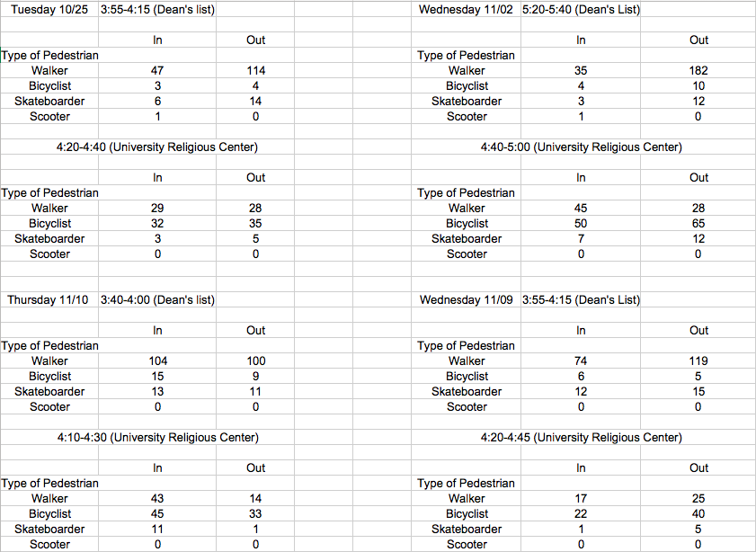

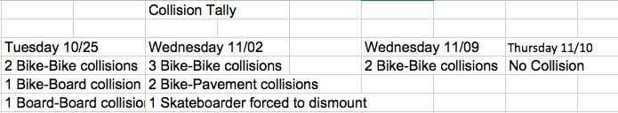
We also created a tally count of the number of mishaps, or collisions we observed at the time of data collection. This helped us analyze the number and nature of accidents taking place.

The raw data was then processed to provide interesting results.

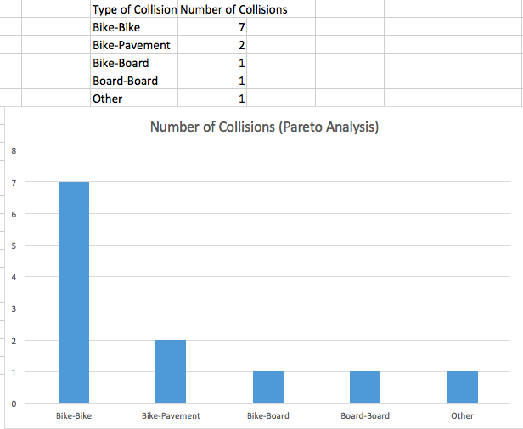

The pareto chart above was created by processing the collision tally. The chart shows that most collisions at the intersection were taking place due to biker-biker collisions. Thus, our goal was to reduce the number of collisions by minimizing biker-biker collisions.

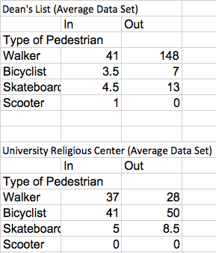
The table above is an average of the data collected 4 times. It shows the number and type of pedestrians crossing both the intersections on average in a 20-minute time interval.

The following data was then graphed to create the following bar charts.
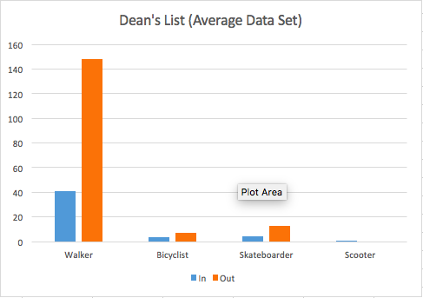

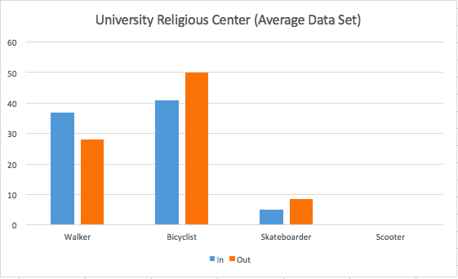
The chart for Dean’s List suggests that most pedestrians were walkers, whereas the chart for University Religious Center shows that the frequency of bikers was highest. This interesting phenomenon can be attributed to the concept of self-organization, in which is the natural arrangement of any process or system.

Along with data collection, we also thoroughly observed the vicinity and noted down some of the qualitative observations we believed would be helpful in providing insights for improvement strategies.

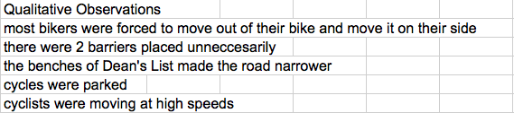

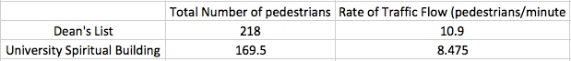

The table above presents the rate of traffic flow on both the intersections, measured in the number of crossing pedestrians per minute.

Flowcharts
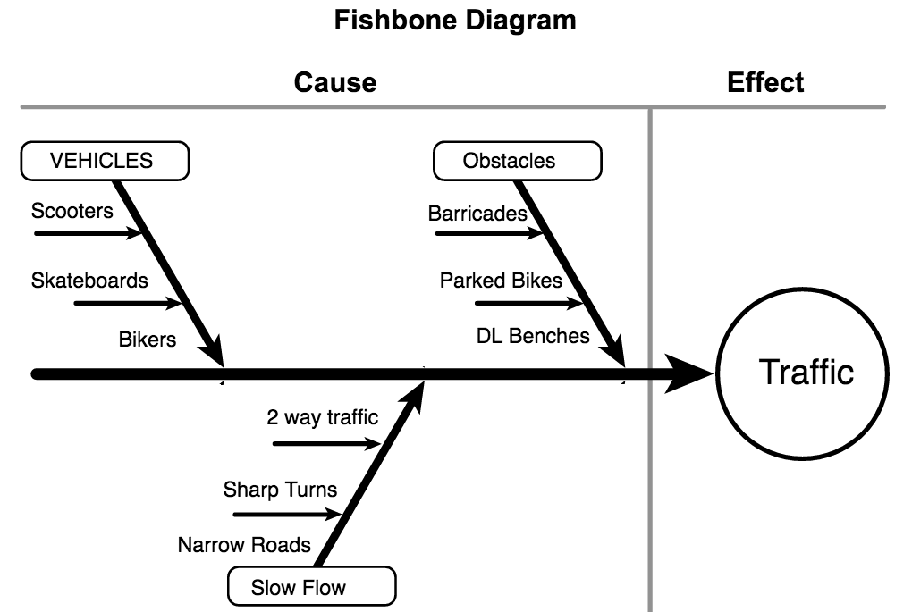
- From our Fishbone diagram, you can see that the root causes of traffic are Vehicles, Obstacles, and Slow Flow. Furthermore, these 3 categories can also be divided into subcategories that help us to visualize which problems we need to tackle.

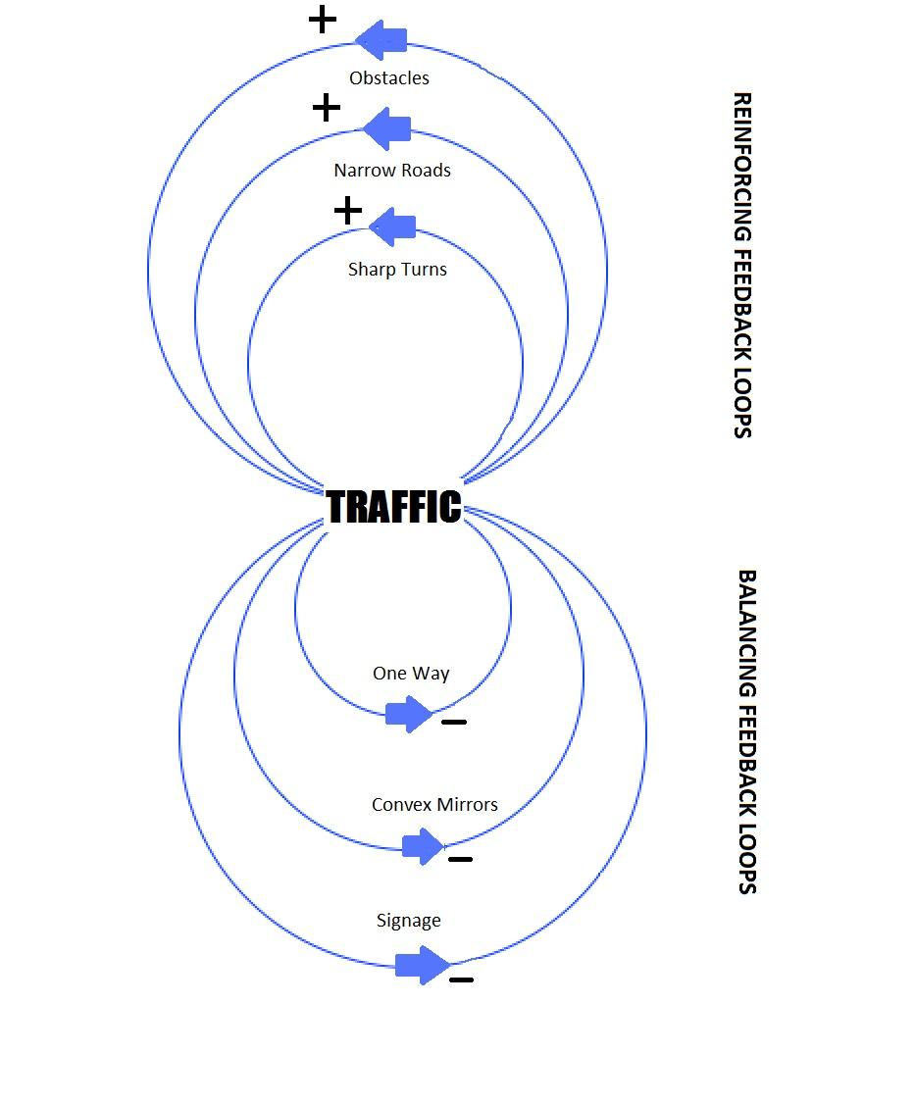

Meanwhile, this causal loop diagram shows what reinforcing and balancing feedback loops are at play. We can see that obstacles, narrow roads, and sharp turns leads to an amplification of traffic and bottlenecks. On the contrary, balancing feedback loops such as convex mirrors and informative signs help to minimize traffic by reducing the traffic density and also minimizing the risk of collisions.

Traffic Survey

Product Survey Distributed:

Below is the survey that was distributed to 44 different individuals:
- What mode of transportation do you most often use?
- Which of these slow you down the most when getting to where you need to go?
- How many times do you almost hit or get hit by another biker, skater, walker, etc. (Daily)
- How frustrated do you get whenever you can't weave through foot traffic on a scale of 1 to 10 (too many pedestrians/ bottleneck effect) ?
- How often do you actually use the bike paths?
- Do you use any forms of signaling while on a bike or skateboard?
- If you answered sometimes/never to the question above, would you start to if you knew it would improve traffic flow?
- Besides signaling, how else would you improve traffic flow at these intersection?

These were the survey questions we asked. We wanted to conduct our survey so that our target audience would be able to give us their own feedback rather than solely relying on our own experiences. We chose these questions to give us a general idea of how a majority of people felt towards this intersection.

Project Survey Results:

Question 1: What mode of transportation do you most often use?

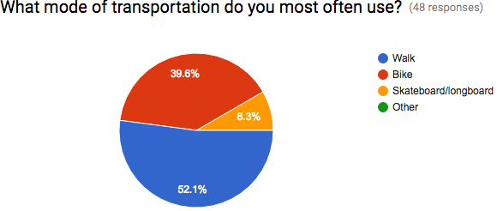

Interpretation: We can see that the majority of pedestrians are walkers. The next biggest majority are bikers followed by skateboarders. What comes as a surprise was that no one put “other” (scooters, wheelchairs, hoverboards). There is a bigger percentage of walkers than we originally anticipated. As a result, we will be paying closer attention to the bikers and boarders’ needs.

Question 2: Which of these slow you down the most when getting to where you need to go?
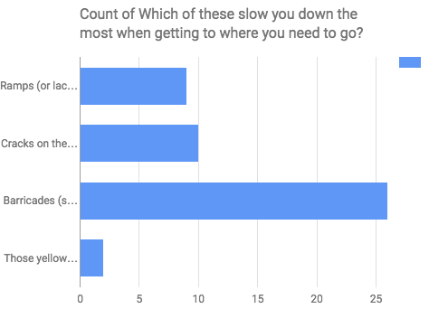

Interpretation: From these results we can see that the biggest obstruction for pedestrians are the barricades. There are several barricades in our specific intersection because of the construction of the finger fountain. However, the barricades do nothing but create a bottleneck effect. Beyond the barricades, cracks on the ground, ramps, and speed breakers also serve as a deterrent for cyclists and skateboarders. More specifically, the lack of ramps create a difficulty in the transitioning from sidewalk to road and vice versa. From these, we can see that USC should create more ramps to accommodate cyclists and also get rid of speed breakers since they don’t slow people down like they’re supposed to.

Question 3: How many times do you almost hit or get hit by another biker, skater, walker, etc. (Daily)
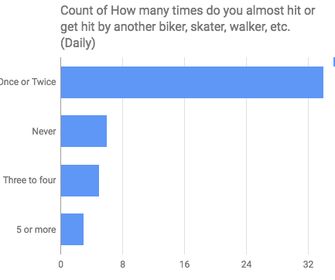
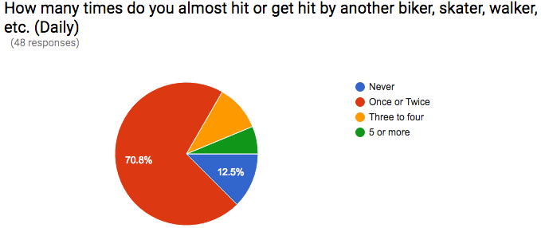
Interpretation: Again, this changed our perception of how big of a problem this actually is. We thought there going be less collisions and pedestrians bumping into each other. However, from this survey, we see that 87.5% of pedestrians collide or almost collide with another pedestrian every day. In the most extreme circumstances, we have 6.3% of pedestrians who get hit or almost hit 5 times or more daily. This serves as a huge safety hazard. Contrary to what the barriers are supposed to do (provide safety), they do the opposite by reinforcing collisions via a bottleneck effect. Additionally, the reason why we also asked if you almost get hit is because we believe the possibility of almost crashing is dangerous in itself because it affects traffic flow very quickly.

Question 4: How frustrated do you get whenever you can't weave through foot traffic on a scale of 1 to 10 (too many pedestrians/ bottleneck effect) ?

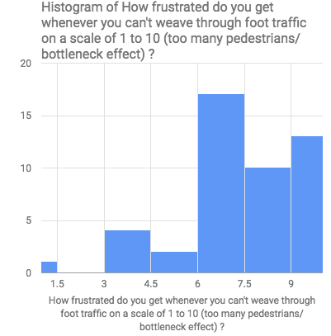
Interpretation: The purpose of our project was to not only alleviate the traffic but also the stress created by it. On a scale of one to ten, the average amount of stress for our respondents was around 7.4 indicating that the condensed traffic affected people negatively. From these results, we can see that there is a high level of frustration whenever there is a bottleneck effect, and people can’t weave through traffic to get to their location on time. Thus, this project not only helps people get around in a safe and efficient manner, but also reduces college students’ stress.
Stats:

Question 5: How often do you actually use the bike paths?

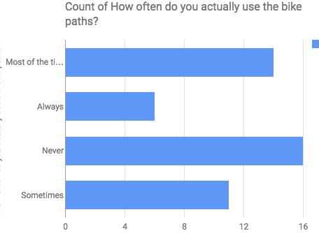
Interpretation: We posed this question to see how viable it would be to add a bike path on and around this intersection. But, after the survey, it became apparent that adding a bike path would be useless since a huge plurality refuse to use it anyways. Instead, we will be opting for other solutions.

Question 6: Do you use any forms of signaling while on a bike or skateboard?

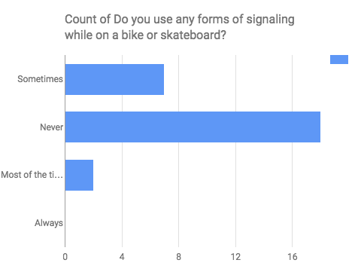
Interpretation: When talking about different types of solutions in the beginning, using some form of signaling became the most obvious. This question tries to see how pedestrians view hand signaling. As expected, the results show that 2/3rds of our sample has never used hand signaling when on a bike or skateboard. This not only tells us why there are so many collisions on campus, but also tells us that there is a huge potential for change.

Question 7: If you answered sometimes/never to the question above, would you start to if you knew it would improve traffic flow?

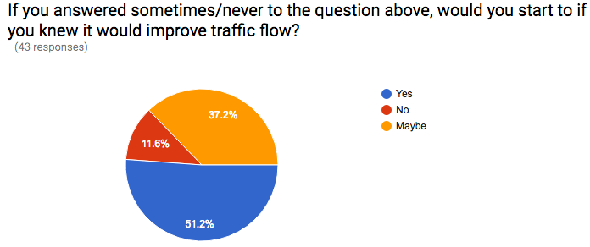

Interpretation: This question is a follow up to question 6. These results prove that the majority of students will use proper hand signaling in order to prevent collisions and improve traffic flow. Consequently, we are going to come up with a proper signaling tutorial and a quiz to go along with it. Once that is done, we are going to talk to DPS to see if they have any suggestions, and whether this would be feasible to implement to incoming students.

Question 8: Besides signaling, how else would you improve traffic flow at these intersection?

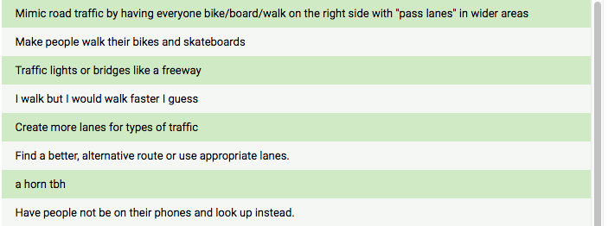

Interpretation: This open-ended question allowed our survey takers to voice their own concerns so that we can see what issues or solutions we might not have considered. Specifically, these results agree with our proposals of creating alternate routes while also trying to educate pedestrians.

Solutions

These charts and observations were used by everyone, and potential solutions were then suggested.
1. Some of the suggestions we brainstormed were-
2. Clearing Obstructions like barriers and parked cycles
3. Signs for commuters stuck on the sides of the pathways
4. Use of convex mirrors to prevent sharp turns from causing accidents
5. One way system
6. Separate lanes for walkers and bikers
7. Bike safety and education quiz
8. Finding the most efficient routes

These suggestions were then carefully evaluated-

The charts suggest that the frequency of bikers in USP was high, whereas in DL, the frequency of walkers was high. We hypothesized that the reasons bikers preferred USB was because there are no barriers, and the road is more open as compared to the DL road.
Thus, the separation of bikes one way (USP) and walkers one way (DL) was suggested. However, this suggestion might not be effective as the Pareto chart for Types of Collisions shows that most collisions takes place by Bike-Bike collisions by bikers moving in opposite directions. Thus, the new system would not prevent this.

We then contemplated whether a one-way system would be effective, as it would prevent collisions between pedestrians travelling in opposite direction. Our data showed that the number of commuters coming into campus (total) was much lower compared to the number of commuters going out of campus (133 as compared to 254.5). Thus, the traffic density would be vastly different on both the pathways, making the system inefficient.

The use of convex mirrors would be effective as it reduces the threat of collisions on right angled turns by providing a view of the other path in advance.

The main observation was that there were several constructions barriers placed unnecessarily (cycles were parked as well), which reduced the width of the narrow pathways further, reducing the efficient movement of traffic, and increased the tendency for accidents. Thus, we decided to remove these obstructions and hence make traffic flow optimal for the pathway, thus minimizing the risk of accidents taking place.

Route Optimization

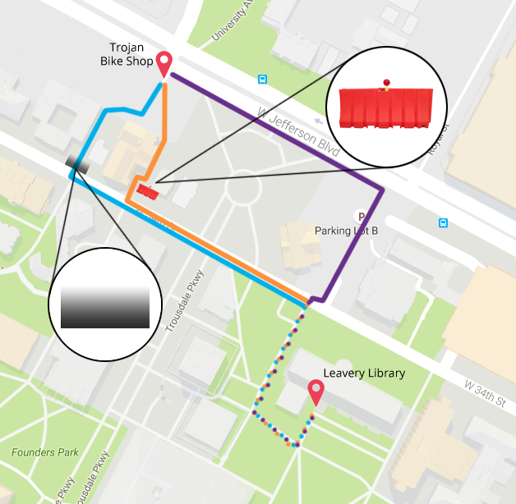

In this graphic, we see the three different routes that we’ve analyzed. Consistently, our test have proved that, in any form of transportation, the navy blue route is the most efficient way to get from tommy’s bike shop to leavey library. The second most efficient route would be the light blue path (through the University Religious Center), and the worst route to take would be the green line, through Dean’s List. It’s easy to see why these results have come about. The green line contains an orange barricade that blocks pedestrians not only in front of dean’s list but also by the sides of taper hall and in front of the JEP house. These barricades, along with the already-to-begin-with narrow pathway, create an extreme bottleneck effect that reduces the “flux” of people that can go through.

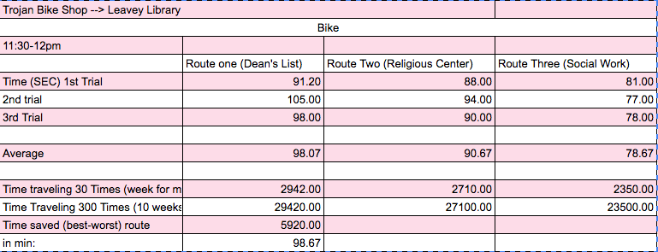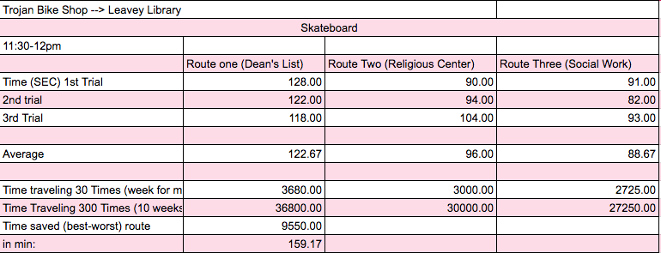
The two spreadsheets above displays all the data I’ve taken on November 17, 2016 via bike and skateboard. Here, I’ve taken three trials for three different routes. These routes were chosen by the group as the most viable route from the intersection of Adams and University Avenue to Leavey Library. We chose the Adams and University Avenue as our start point not only because that’s where we based our study one, but also because a majority of students must cross this intersection to be able to get onto campus. Leavey library was chosen as the endpoint as it is where the majority of students study throughout the day.
From these results, the most efficient route is through the social work building followed by the religious center. The worst route to take, which is also the most used one, is through the dean’s list pathway. Thus, we can see that if one were to take the most optimal route, which in this case is through the social work building, he/she would be able to save 160 minutes. And while this might not seem significant at first glance, imagine how many collective minutes would be saved if everyone were to take the most efficient route. In addition, the more people leave the busy route for the optimal route, the less busy and more safe campus traffic will be.
The most interesting observation we saw when we compared the two modes of transportation is how skating had the fastest time on the blue line. We believe this can be attributed to the size of the bicycles and the increased likelihood of collisions and the difficulty of weaving through the people. In addition, speeds for all measurements could not be ensured to be identical which creates common variation.
Moreover, I chose to look at how much time we’re saving by extrapolating the result 300 times because I thought that was a fair assumption of how many times a student will go across campus in a given month (10x a day for a student to get to class/work and back to their apartments times 30 for the month).
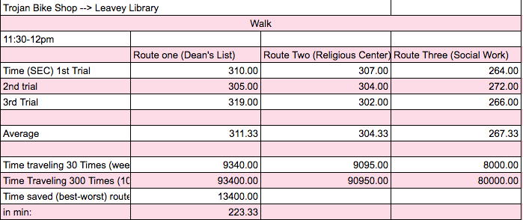
We also took different readings for the amount of time it took to walk through these routes. The order of routes in terms of using the least of amount of time is the same as compared to the time taken to bike and skateboard through these routes. The Social Work route was the quickest, followed by the Religious Center route and the Dean’s List route respectively. By extrapolating the data, we can also observe that the amount of time saved by travelling on the same route is roughly 223 minutes, which is about 4 hours. This gives an estimate of the fact that if other such routes are optimized, a student saves a lot of time!

Signaling and Bike Safety Quiz

1. Is it OK to ride a bicycle while wearing headphones?

A. Never
B. Only on busy roads
C. Only on residential streets

2. Before entering a roadway, you should look:

A. Left
B. Right
C. Left, centre and right

3. You should observe the following at a four way stop.
A. The bicycle/vehicle that stops first should go first
B. Go first as soon as you arrive
C. Both bicycle/vehicle go at the same time

4. It’s important to check over your shoulder every time you:
A. Are going to change lanes
B. Are going to make a turn
C. All of the above

5. Visibility is important to staying safe on the road. Always make sure you have:
A. Good working lights and reflectors
B. Light-toned clothing
C. All of the above

6. A bell is an important safety feature because:
A. It informs others you are passing
B. It keeps you from getting bored
C. It’s fun to play with

7. If a cyclist dismounts completely and is walking beside and pushing their bicycle:
A. They are considered by law to be a pedestrian
B. They are considered by law to be a vehicle
C. They are breaking the law

8. Stay well behind large vehicles because:
A. They may not like bicycles
B. They may not see you
C. They may want to back up

9. When riding:
A. Ride with your head down
B. Ride with your head up and look well ahead
C. Look mostly in your mirror

10. To make sure that cars see you:
A. Always enter the intersection either ahead of or behind the cars
B. Pull out in front of traffic
C. Always enter the intersection without stopping

11. When riding your bicycle:
A. Only signal on busy roads
B. Obey all traffic laws
C. Ride on the left side of the road

12. Before entering an intersection, you should look:
A. Left
B. Right
C. Left, centre and right

13. Before turning right at an intersection, you should:
A. Look left
B. Look right
C. Shoulder check and look left and right

14. The ABC’s of bicycle maintenance are:
A. Air
B. Brakes, Bars and Bell
C. Chains and Crank
D. All of the above

15. When do most bicycle injuries occur?
A. Evening
B. Afternoon rush hour
C. Morning
D. None of the above

16. Ride in a straight line at least how many metres away from parked vehicles?
  - 2
  - 4
  - 1
  - 5

17. If the right curb lane is about to become a right-turn only lane and you wish to go straight:
  - Keep going
  - Stop
  - Shoulder check, signal and move to the adjacent through lane

18. To cross tracks safely, cross the tracks at a:
  - Right angle
  - Left angle
  - Centre
  - Do not cross

19. When riding your bicycle you should be:
  - Alert
  - Wary
  - Seen
  - All of the above

20. What is a common vehicle-bike collision?
  - Driver opening the car door
  - Driver turning left and right
  - Driver passing
  - All of the above

Conclusion and Findings

One of our biggest measures of success was to reduce the number of collisions by half. After implementing some of our solutions (removing barriers and clearing parked bicycles) we managed to top that and had no collisions during our observation.

In retrospect, the ISE group project was an enriching experience for all of us. From figuring out a problem that we wanted to address, to executing our plans, we learnt about various realms of ISE methods, techniques, and applications. To observe a tangible improvement in the problem we wanted to address was very satisfying, and this is perhaps the motivation for most Industrial and Systems Engineers. The most challenging part of the project was to implement our potential solutions to the problem of traffic on campus. There were several administrative barriers, and technical difficulties which we struggled with at first, but team-work helped us overcome those difficulties.

Individual Team Member Evaluations / Personal Reflections

9. Are you satisfied with what your team was able to achieve in the project? Please explain.

In the beginning, things were a little rocky. Being the upperclassman of the group meant that I had to do most of the logistic work including meeting times, deadlines, assigning tasks, and brainstorming. There was a point in my group where I had been asking to meet up for a week to do one of the homework assignments. I became very frustrated since none of them replied even when I knew they had read the texts. As a result, I followed one of the suggestions our book gave about escaping a system trap. It was to reduce my expectations. To my surprise, this actually worked. The group started doing their task because they were afraid of me completely giving up on them ( of course, however, this is just my speculation). Nonetheless, my team continued to put in effort and we all became proud of how our project turned out. While still satisfied, I wished we could have pursued some of my other ideas which was to create custom bike signals and interview other professors.

10. What ISE knowledge or systems thinking concepts work in the project? What ISE knowledge or systems thinking concepts did NOT work in the project?

Understanding system loops and interconnections worked very well in helping us figure out the root causes of foot traffic bottlenecks. From here, we also applied the organizing charts and tools we learned in class such as a fishbone diagram and causal loops. In addition, some of the weird phenomenon that puzzled me could also be explained via ISE methods. For example, it was due to self organization
On the contrary, there were ISE concepts that worked to delay our group. For instance, competing goals played a role in the project since different members had different expectations, which pulled the project into different directions.

11. What knowledge do you wish to learn more for future improvement projects?

I wish I could learn how to incorporate more software programs into future projects. For example, learning how Arena could have been applied to this project. Even simple things, which some of the freshman might have not learned such as slack would have been good. Also, learning how to provide better statistics based on data collected would have also been good. This could be somewhat difficult since a lot of the class have not been introduced to probability or statistics.

12. Does this project help you better understand your interest in ISE?

This project helped me see the applications of ISE so I think it was a good exercise to solidify my interest in the field. At first, I had no idea how those systems concepts we learned in the beginning of the semester would actually relate to real life projects. However, through this project I saw how they applied when trying to tackle a problem and create a change. Overall, in this project, I was able to see how to apply theoretical concepts into a real solution.

13. Does this project help you by creating a changed or new perspective about your study plan or future career interest?

No, not exactly. While it taught me a lot about ISE, I don’t think the project changed my mind about it per say. If anything, it just made me more excited to get to work in bigger and broader projects. After all big project management is what I want to pursue in the future, and I’m glad this gave me a good foundation to start with.

14. Overall, how would you evaluate this learning experience?

I’d say this was a valuable learning experience because it was my first exposure to a hands on application of the theories we’ve learned. I prefer to do a lot of real-world projects to learning concepts from a book and I think this was the perfect setting to do so.

15. Please include a rating of each team member’s performance for the project. The rating scale is:
1 = Far below fair contribution
2 = Below fair contribution
3 = Meeting fair contribution
4 = Exceeding fair contribution
5 = Far exceeding fair contribution

Naman - 4
Naman was not very responsive in the beginning, but became really responsible and dependable towards the end. He was in charge of creating most of the data interpretations and some of the graphs. You can tell he knew what was going on throughout the whole project and was good at applying class concepts when needed.

Vatsal - 4
Vatsal was fairly responsive in the groupme. He showed up to all of the group meetings, and often took a lot of initiative. I remember one time if was only him and I that showed up to a planned group meeting the week before the first presentation day, and we got a lot of work done. Overall, Vatsal was reliable and a team player.
Aprylle - 4
Aprylle didn’t take much initiative, but always did the task she was assigned. She took the job seriously, but didn’t go beyond expectations. She started of very strong, offering good ideas and being enthusiastic during the group meetings. However, this faded a little bit towards the end. Nevertheless, Aprylle was a good and solid teammate to have on this project.
Ali - 1.75
I give Ali a 1.75 for several reasons. For one, he came to our group in the middle of the semester. Although he had very special circumstances for which I understood and sympathized with, I believe he could have offered more support the project. We gave him three tasks for him to do, however he did them very late, and was not able to do a good job because he was never there during the meetings. Communication was also extremely difficult with him.

16. Please provide your suggestion to future students doing this project exercise.

My main piece of advice for students coming into this project would be to have better systems of accountability. This could be done primarily by designating a team leader to set deadlines and make sure everyone is on task. Furthermore, the team leader would be responsible for seeing the project from a bigger perspective and could look for the missing pieces that may have been forgotten. I also believe that having regular group check ins regarding the amount of work to be done would be helpful to ensure everyone is doing an equal amount of research. And most importantly, start as soon as possible!

17. Please provide your suggestion or comments to the instructor regarding the project exercise.

I agree with my last statement regarding the Team Leader position. I firmly believe that, in practice, group projects work better with a designated hierarchy so members have a focal point to direct their comments about the project in terms of workload, deadlines, etc. without having to go to the professor right away. At the same time, I think we needed more group check ins from the professor. If I had not sent that email to the professor once about my group never replying, the project would have been delayed a lot more. In addition, I think giving more group homework (homework where the group has to meet) would be beneficial since it fosters more group camaraderie.

Works Cited

“Motorcycle Hand Signals.” Oakland &Amp; San Francisco Motorcycle Accident Attorney | Michael
Padway &Amp; Associates , Michael Padway &Amp; Associates, www.michaelpadway.com/wp-content/uploads/2013/12/motorcycle-hand-gestures-chart.jpg.

“Test Your Bike Safety Smarts.” CAA National, Canadian Automobile Association,
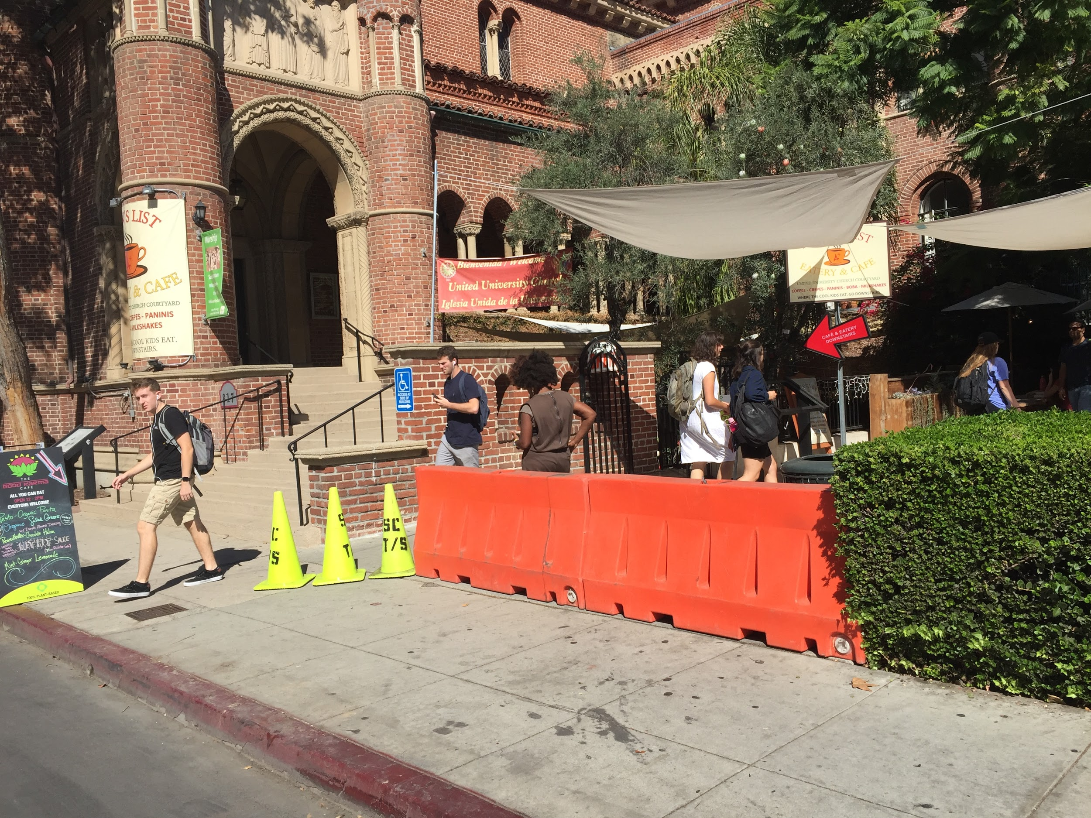
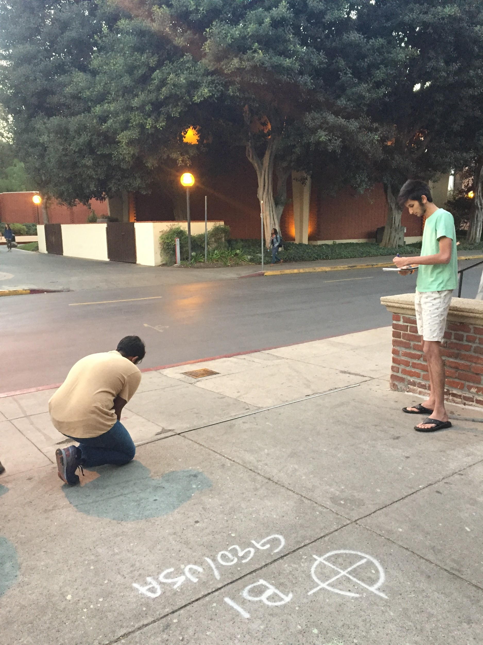
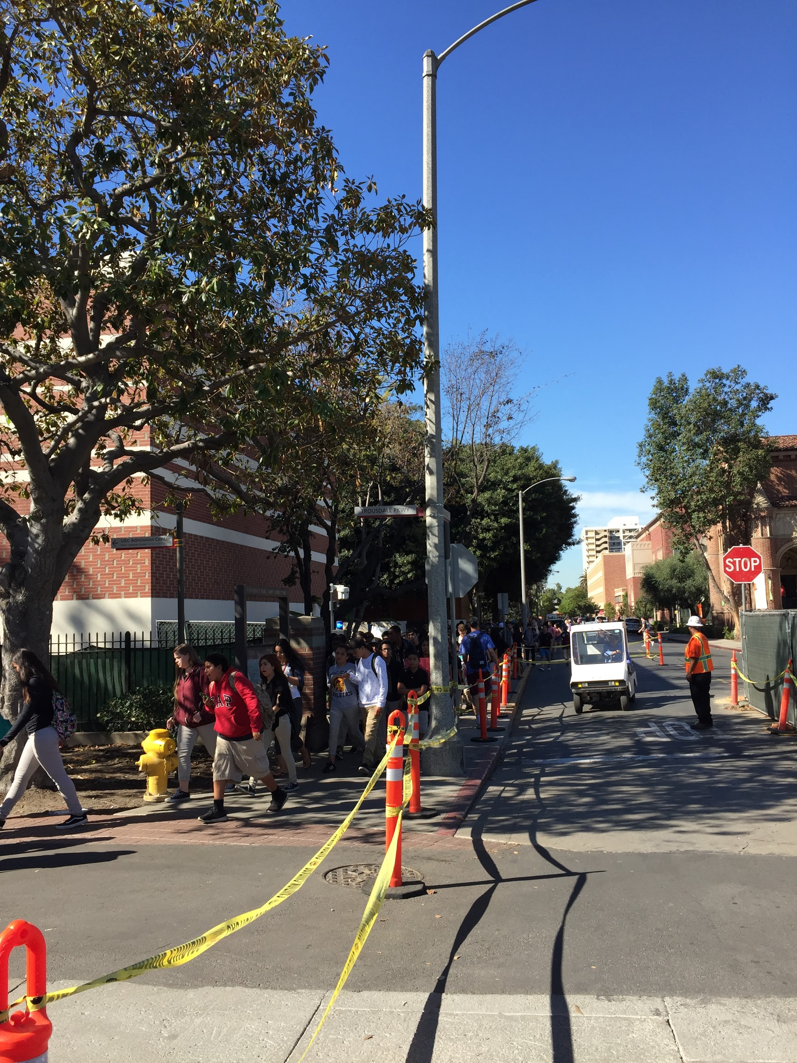
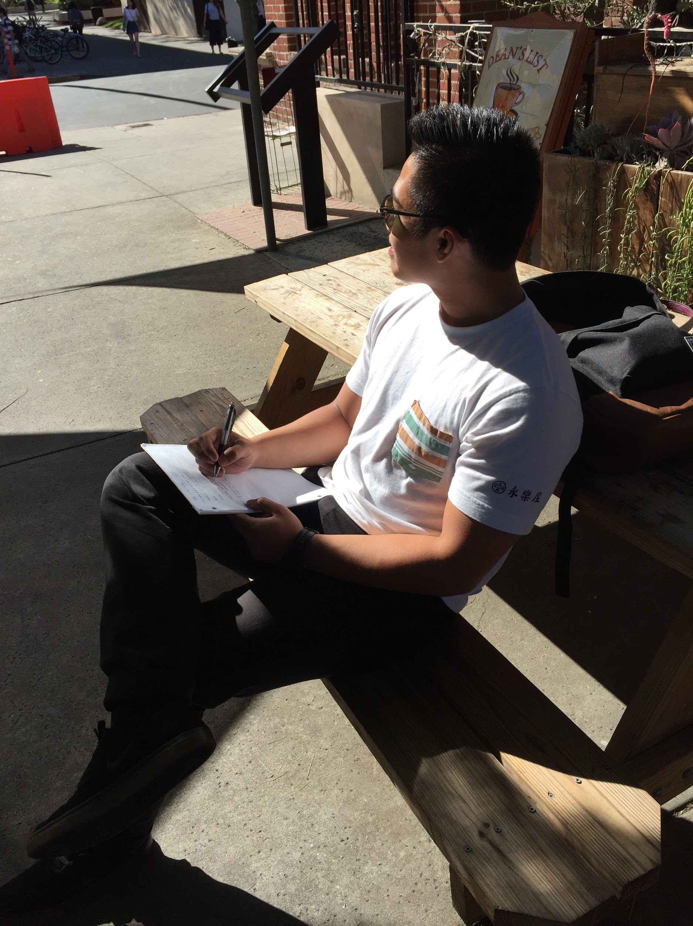
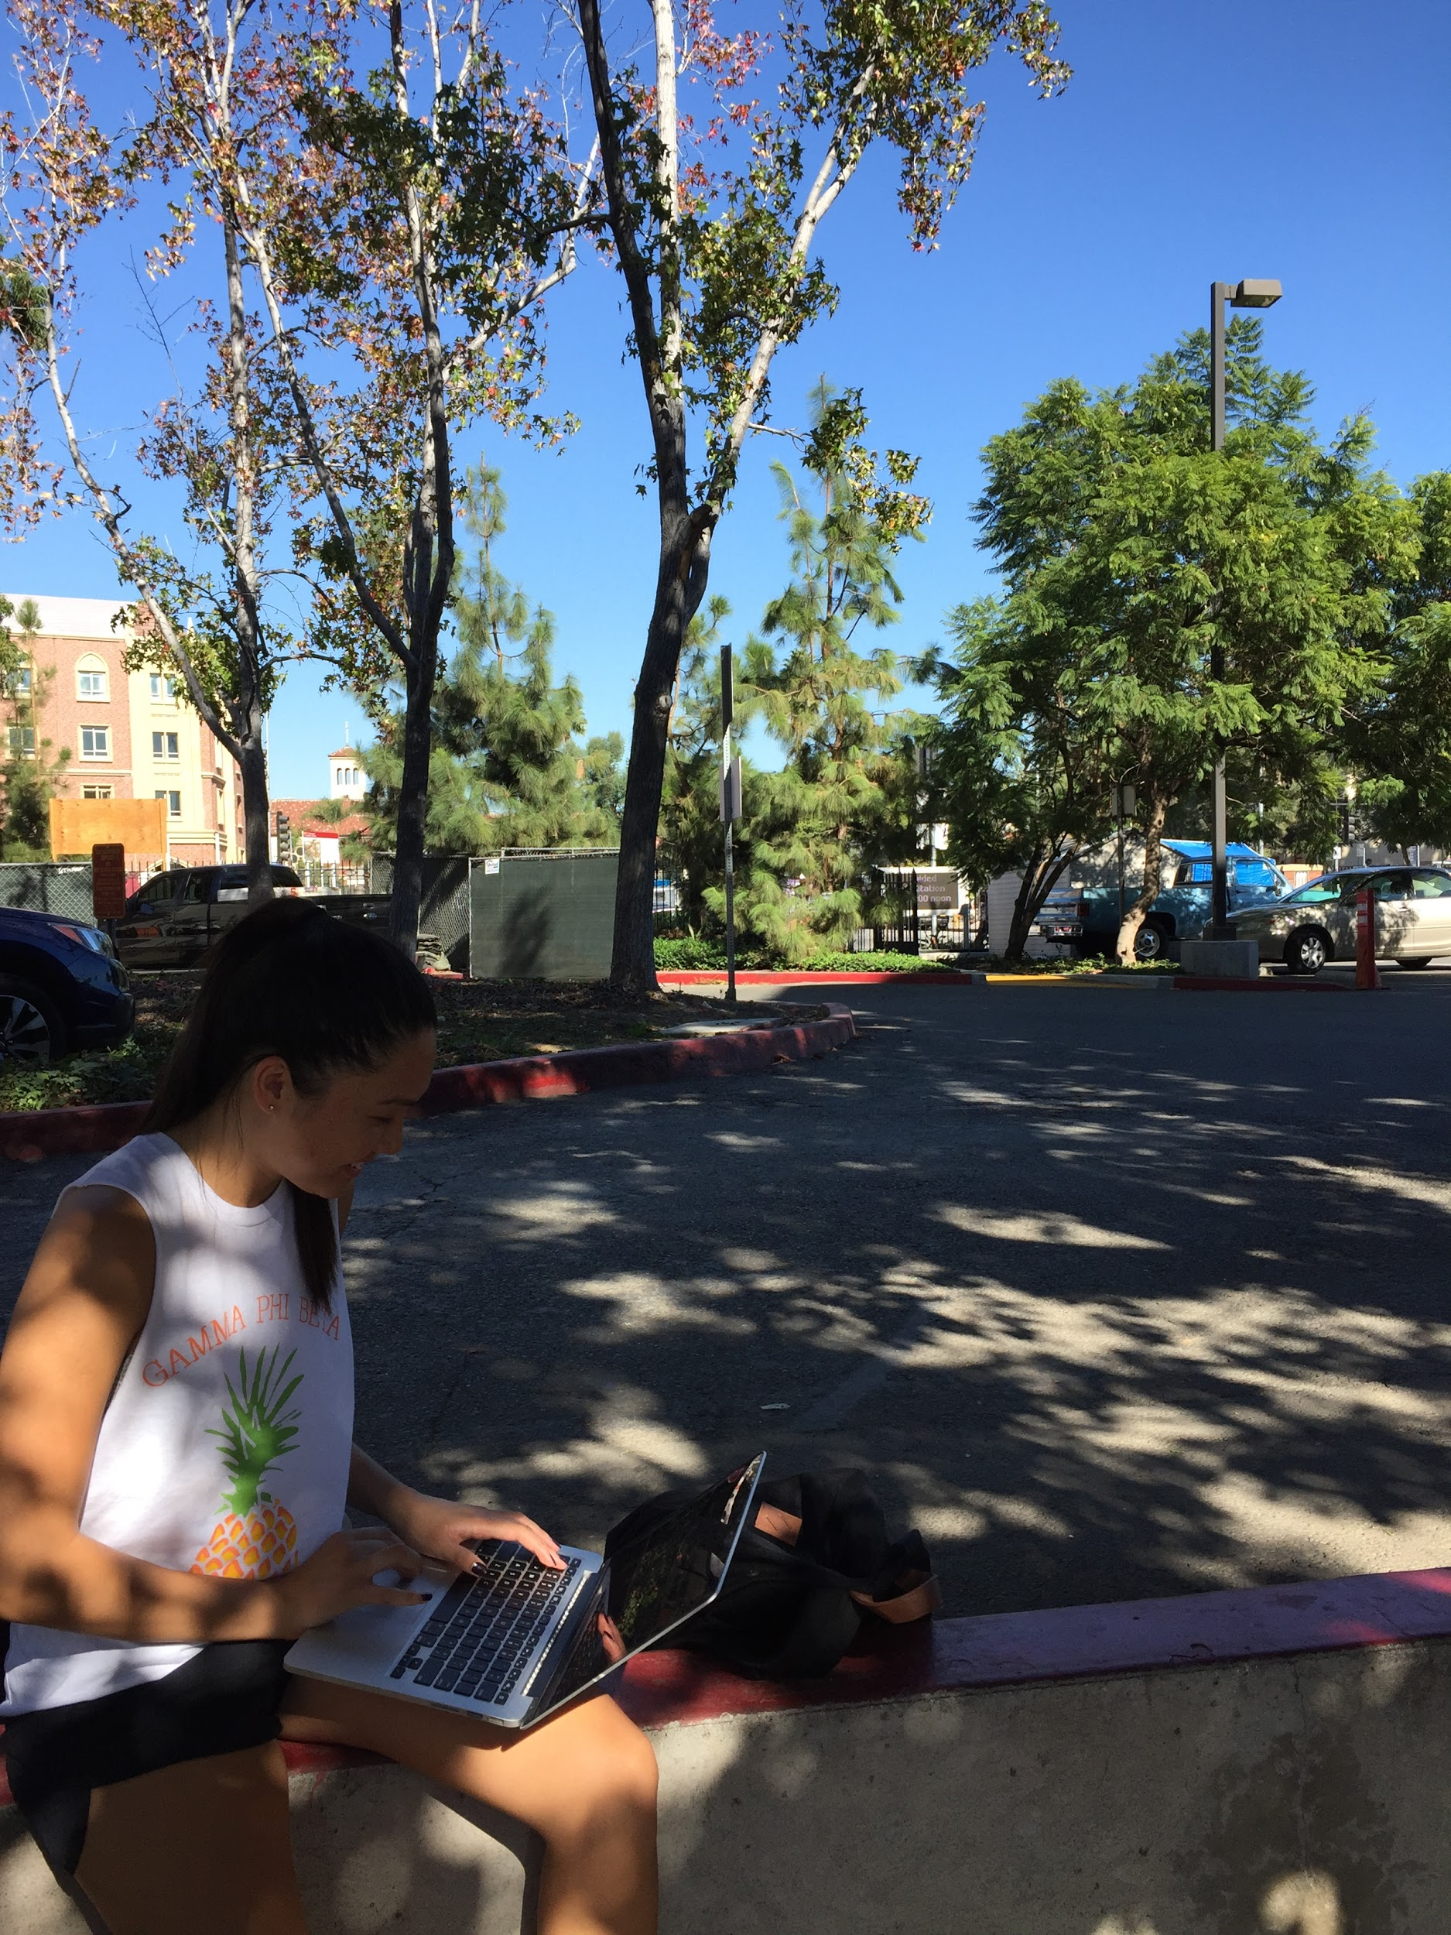
www.caa.ca/bike/bike-quiz/.

